Wyoming Cooperative Fish and

Wildlife Research Unit

Biological Sciences Building, Room 419

Dept. 3166, 1000 E. University Avenue

Laramie, WY 82071

307.766.5415

**REPORT**

**Title of Project: __**Elk Pop-II **___________________________**

**UW Grant #: __**4211.11541.1000897**________________________**

**Agency: _________**Wyoming Game and Fish Department**__**

**Agency #: __**001202**__________________________**

**Type of Report: __**Annual Report**___________________**



2010-2011 Annual Report

**A quantitative evaluation of survey efforts to model, monitor, and manage Wyoming ungulate populations**

Thomas Morrison (Postdoc) & Matt Kauffman (Unit Leader)

Wyoming Cooperative Fish and Wildlife Research Unit, Laramie, WY

Bob Lanka & Bill Rudd

Wyoming Game and Fish Department

**INTRODUCTION**

The survey, data collection and modeling protocols in place within Wyoming Game and Fish Department have evolved over the years but may not be optimized to allow efficient management of elk, mule deer and pronghorn under current fiscal, logistical, or environmental constraints. The Colorado Division of Wildlife (CDOW) has developed a population model implemented in MS Excel – the ‘Spreadsheet Model’ – which offers a number of practical advantages over the current modeling software, POP-II.

In November 2011,the WGFD and the Wyoming Cooperative Fish and Wildlife Research Unit at the University of Wyoming initiated a project to assess WGFD’s ungulate monitoring and modeling procedures. A postdoc in the Coop Unit, Thomas Morrison, was hired to lead this effort. The overall goal of the project is to assist the WGFD in developing a practical, cost-effective and statistically rigorous methodology for monitoring and modeling WY ungulates, which may include changes to monitoring protocols and a transition to the CDOW’s Spreadsheet model.

**CURRENT OBJECTIVES**

I.  Learn to use the CDOW’s Spreadsheet model and evaluate the software as a possible alternative to POP-II, WGFD’s current modeling software.

II.  Assess the ability of POP-II to estimate herd abundances and population trends. To do this we have asked WGFD biologists to separately model abundance using standardized simulated datasets of mule deer populations, where true abundances and trends are ‘known.’

III. Evaluate the power to detect ungulate population trends under various monitoring approaches and sampling intensities across a range of population densities and growth trajectories. This work will include an economic evaluation of each monitoring scenarios.

**PROGRESS TO DATE**

**Objective I.** Because CDOW’s Spreadsheet model did not include user instructions, we have developed a draft user’s manual and simplified data entry spreadsheet that conforms to WGFD’s current data structure. We have also asked Andy Holland (CDOW’s Big Game Biologist) to model a set of simulated datasets (see objective II) to determine whether they do a better job of estimating abundance and detecting population trends than POP-II.

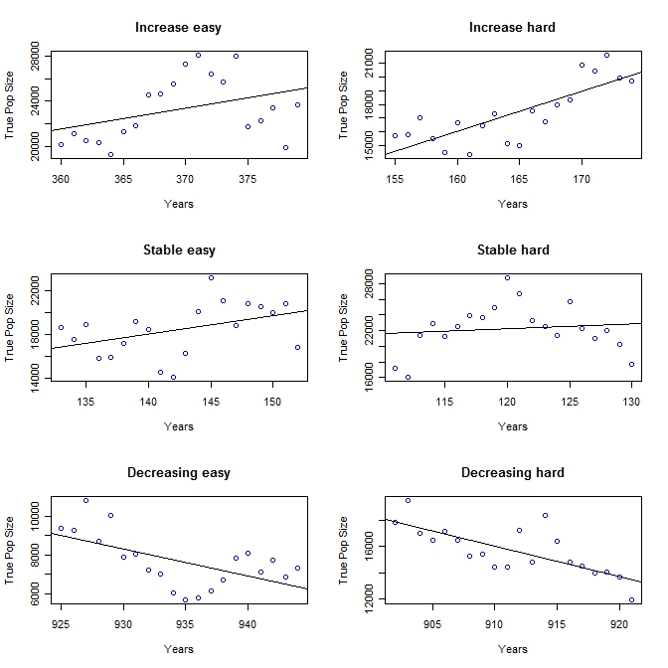

**Fig 1**. Example of the six simulated datasets of mule deer given to WGFD biologists to model in POP-II. Two populations were increasing, two were stable and two were decreasing over 20-year periods.

**Objective II.** We generated simulated mule deer monitoring datasets based on existing WGFD data (classification and harvest data). These datasets were intended to mimic existing data but allow us to manipulate population trends and to know the true population sizes. We distributed these datasets to state biologists and asked each biologist to model them in POP-II. These data will reveal the accuracy and precision of POP-II and a summary of the results will be present at the Big Game Biologist meeting in August 2011.

**Objective III**. We have developed a framework for analyzing alternative monitoring protocols. We will assess four main categories of monitoring protocols: Quadrat-based classification counts, Quadrat-based abundance estimates, Sightability models, Survival. Using the CDOW Spreadsheet Model, we will compare the trade-off between sampling intensity (and cost) and precision under a number of different monitoring (n=36), population growth (n=7) and density (n=2) scenarios. An example of potential results is shown below.

Hypothetical results



**Fig 2.** Hypothetical relationships between different combinations of monitoring protocols (ordered along x-axis by ‘effort level’) and the probability of detecting a population decline for three declining populations. This analysis basically shows the relative ‘bang for the buck’ of each monitoring scenario. For example, the highest effort level (far right) would likely involve quadrat-based classification counts, sightability surveys every collecting estimates of survival every 3 years. The x-axis variable ‘Scenario Number’ should be directly related to cost and the y-axis variable ‘Probability of detecting a population decline’ is roughly equivalent to an estimate of model ‘precision’ (i.e., mean square error).