**AN ABSTRACT OF A THESIS**

**SAMPLING AND POPULATION CHARACTERISTICS OF BIGHEAD CARP AND SILVER CARP IN THE TENNESSEE AND CUMBERLAND RIVER SYSTEMS**

Josey L. Ridgway

Master of Science in Biology

The invasive Bighead Carp *Hypophthalmichthys nobilis* Richardson and Silver Carp *H. molitrix* Valenciennes (collectively referred to as bigheaded carps) were introduced to the U.S. in the 1970s to control noxious algae blooms in polyculture ponds. Fish subsequently escaped and by the 1980s bigheaded carps were widespread and established in the upper Mississippi River, lower Missouri River, and the Ohio River and some of its tributaries. In the lower reaches of the Tennessee River and Cumberland River systems, bigheaded carps were systematically sampled in 2015 and 2016 using multiple gears. Nearly 12 km of experimental gill nets captured 363 adult Silver Carp and 7 Bighead Carp. Hoop nets (n = 96) captured only 2 Silver Carp and 2 Bighead Carp. Twenty-eight hours of electrofishing collected 146 adult and 214 young-of-year (YOY) Silver Carp. Cast nets (n = 480 throws) captured 15 YOY Silver Carp. Bighead Carp and Silver Carp in Kentucky Lake and Lake Barkley reached large sizes and were long lived. The maximum total lengths (TL) and ages were 1,385 mm TL and 22 years for Bighead Carp and 1,005 mm TL and 13 years for Silver Carp. The Silver Carp populations in both reservoirs had the same strong year classes (2010, 2011, 2012, 2015) and similar growth rates which were faster than what has been reported for other populations around the globe. Silver Carp in both reservoirs were similarly robust, and more robust than Silver Carp below Barkley Dam, suggesting food resources and habitat are ideal in the reservoirs. Some YOY Silver Carp were collected 180 and 110 river kilometers upstream in Kentucky Lake and Lake Barkley, respectively, and they may represent the first evidence of natural reproduction in those reservoirs or their tributaries. The catch-per-unit-effort (CPUE) of adult Silver Carp in gill nets was similar in each reservoir, and they are already a major component of the fish assemblages vulnerable to gill nets. In electrofishing samples the CPUE of adult Silver Carp was higher in Lake Barkley but the CPUE of YOY Silver Carp was similar in each reservoir. Future efforts to control bigheaded carps in Tennessee waters should include studying the efficacy of barriers at navigation locks, determining where natural reproduction is occurring, and increasing the commercial harvest of both species.

**SAMPLING AND POPULATION CHARACTERISTICS OF BIGHEAD CARP AND SILVER CARP IN THE TENNESSEE AND CUMBERLAND RIVER SYSTEMS**

___________________

A Thesis

Presented to

the Faculty of the College of Graduate Studies

Tennessee Technological University

by

Josey Ridgway

___________________________

In Partial Fulfilment

of the Requirements of the Degree

MASTER OF SCIENCE

Biology

___________________________

August 2016

Copyright © Josey L. Ridgway, 2016

All rights reserved

**CERTIFICATE OF APPROVAL OF THESIS**

**SAMPLING AND POPULATION CHARACTERISTICS OF BIGHEAD CARP AND SILVER CARP IN THE TENNESSEE AND CUMBERLAND RIVER SYSTEMS**

by

Josey L. Ridgway

Graduate Advisory Committee:

_____________________________ __________________

Phillip W. Bettoli, Chairperson Date

_____________________________ __________________

Joshuah Perkin Date

_____________________________ __________________

Michael Allen Date

Approved for the Faculty:

_____________________________

Mark Stephens

Dean

College of Graduate Studies

_____________________________

Date

DEDICATION

To my family and wife for

their love and support

**ACKNOWLEDGEMENTS**

Primary funding for this research was provided by the Tennessee Wildlife Resources Agency. Other funding and support was provided by the Center for the Management, Utilization, and Protection of Water Resources at Tennessee Technological University, and the USGS Tennessee Cooperative Fishery Research Unit at Tennessee Technological University.

I would like to thank my advisor, Dr. Phillip Bettoli, for his guidance and expertise, which instilled a wealth of understanding and appreciation for fisheries research and management. I would like to thank my committee members, Dr. Joshua Perkin and Dr. Michael Allen for improving this study, and being an important component of my graduate education. I would like to thank Dennis and Ben Duncan for their insights as commercial fisherman in Kentucky Lake and Lake Barkley, and those who helped in the field including Cole Harty (TTU), Dr. Mark Rogers (USGS), and Frank Fiss, Tim Broadbent and their staff (TWRA). I appreciate Robin Calfee (USGS), Duane Chapman (USGS), Allison DeRose (Murray State University), Emily Pherigo (USFWS), Neal Jackson (KDFWR), and David Roddy (TWRA) for their eagerness to help after receiving my inquiries; and a special thanks goes to Kevin Irons (IL DNR) for inviting me to observe how Illinois commercial fishers collect bigheaded carp.

**TABLE OF CONTENTS**

Page

LIST OF TABLES ……………………………………………………………………..viii

LIST OF FIGURES ……………………………………………………………………...ix

CHAPTER ONE - INTRODUCTION………………………………………………….....1

CHAPTER TWO - STUDY AREAS………..……………………………………………7

Kentucky Lake…………………………………………………………………….7

Lake Barkley………………………………………………………………………8

CHAPTER THREE - METHODS……………………………………………….………..9

Field Sampling…………………………………………………………………….9

Bycatch…………………………………………………………………………..13

Population Analyses……………………………………………………………...13

Statistical Tests…………………………………………………………………..14

CHAPTER FOUR – RESULTS…………………………………………………….…...16

Gear Efficacy and Relative Abundance………………………………………….16

Bycatch…………………………………………………………………………..18

Distribution………………………………………………………………………19

Population Characteristics……………………………………………………….19

CHAPTER FIVE - DISCUSSION………………………………………………………24

Gear Efficacy…………………………………………………………………….24

Leading Edge…………………………………………………………………….28

Age and Growth………………………………………………………………….28

Page

Reproductive Ecology……………………………………………………………30

Robustness……………………………………………………………………….32

Abundance……………………………………………………………………….33

Conclusions and Future Research………………………………………………..34

REFERENCES…………………………………………………………………………..38

TABLES…………………………………………………………………………………46

FIGURES ………………………………………………………………………………..48

APPENDIX – Gill Net Data …………………………………………………………….64

VITA……………………………………………………………………………………..66

**LIST OF TABLES**

Table Page

1. Standardized sampling effort in 2015-2016, non-standardized electrofishing effort below five dams, and number caught and CPUE of Bighead Carp, Adult (> 400 mm TL) Silver Carp, and YOY Silver Carp. Effort was in terms of net-night for gangs of gill nets, three-day soaks for tandem hoop nets, throws for cast nets, and number of 10-min electrofishing samples in Kentucky Lake and Lake Barkley. Electrofishing effort downstream of five dams is reported as minutes of

pedal time.…………………………………………………………………………... 46

1. Mean total lengths (TL, mm) and weights (g) by age for male and female Silver Carp collected in the Tennessee River, Duck River, and

Cumberland River in 2015-2016…………………………………………………….47

**LIST OF FIGURES**

Figure Page

1. The lower Tennessee River and Cumberland River in Tennessee and Kentucky, and the lower Duck River where bigheaded carps were

sampled in 2015-2016………………………………………………………..............48

1. Locations where gill nets and hoop nets were deployed to collect

bigheaded carps in 2015-2016.………………………..……………………………..49

1. Total length-frequency distributions by gear type for Silver Carp captured using four different gears during standardized and exploratory, non-standardized sampling () in the Tennessee River, Duck River, and

Cumberland River in 2015-2016………………………………………………….…50

1. Percent frequency of fish collected in experimental gill nets in Kentucky Lake and Lake Barkley, 2015-2016. “Native Planktivores” are Bigmouth Buffalo*,* Gizzard Shad and Paddlefish. “Other Carps” are Grass Carp and Common Carp. “Angler Species” are represented by Centrarchidae (4 species), Cluepidae (1 species), Ictaluridae (3 species), Moronidae (3 species). “Other Species” are represented by Amiidae (1 species), Catostomidae (3 species), Lepisosteidae (3 species) and

Sciaenidae (1 species)…………………………………………………………...…...51

1. Total length-frequency distributions by mesh size for Silver Carp collected in gill nets during standardized and exploratory, non-

standardized sampling in Kentucky Lake and Lake Barkley, 2015-2016…….......…52

1. Locations where cast nets and electrofishing samples were collected,

2015-2016……………………………...…………………………………………….53

1. Locations where 10 Bighead Carp were collected, 2015-2016….…………………..54
2. Locations where 787 Silver were collected in 2015-2016. Three Silver

Carp were observed but not captured in the Pickwick Dam tailwater……….…...….55

1. Total length-frequency distributions for Bighead Carp collected in

Kentucky Lake and below Kentucky Dam and Barkley Dam, 2015-2016….…….....56

1. Total length-frequency distributions for Silver Carp collected using all gears during standardized and exploratory, non-standardized sampling in

Kentucky Lake, Lake Barkley, and below Barkley Dam in 2015-2016……………..57

Figure Page

1. Log10total length- log10weight relationships for Silver Carp longer than

400 mm collected in Kentucky Lake and Lake Barkley, 2015-2016………………..58

1. Log10total length – log10weight relationships for Silver Carp longer than

400 mm collected in Lake Barkley and below Barkley Dam, 2015-2016…...………59

1. Year classes of Bighead Carp and Silver Carp collected from Kentucky Lake and Lake Barkley using all gears during standardized and

exploratory, non-standardized sampling in 2015-2016……………………………...60

1. Von Bertalanffy growth curves for Silver Carp in Kentucky Lake and

Lake Barkley, 2015-2016……….…………………………….…………………...…61

1. Von Bertalanffy growth curves for Silver Carp in Kentucky Lake and Lake Barkley (this study; observed mean-lengths-at-age are shown), Middle Mississippi River (Williamson and Garvey 2005), Wabash River in Illinois, and the Illinois River (Stuck et al. 2005), Missouri River tributaries in South Dakota (Hayer et al. 2014), India (Tandon et al. 1993 cited in Williamson and Garvey 2005), and Russia (Nikolskii 1961 cited

in Williamson and Garvey 2005)………………………….…………………………61

1. Gonadosomatic index across months (2015 May – December, and 2016 January) for Silver Carp collected from Kentucky Lake and Lake

Barkley, and the Duck River below Columbia Dam………………..………..……...62

1. Locations where 264 YOY Silver Carp were collected, 2015-2016………………...63

**CHAPTER 1**

**INTRODUCTION**

Bighead Carp *Hypophthalmichthys nobilis* Richardson and Silver Carp *H. molitrix* Valencieenes (hereafter collectively referred to as bigheaded carps) are native to large rivers of eastern Asia and have been introduced to every continent in the world excluding Antarctica (Kolar et al. 2007). Bigheaded carps are a popular food source in some countries and have been utilized in several for their perceived ability to control zooplankton and phytoplankton production in polyculture ponds (Kolar et al. 2007). Bigheaded carps were first introduced to the U.S. in Arkansas in the early 1970s for aquaculture purposes in fish ponds (Freeze and Henderson 1982). The Arkansas Game and Fish Commission subsequently propagated and stocked bigheaded carps to assess their utility as a biological control of excessive plankton and nutrients in wastewater lagoons (Henderson 1983). Soon thereafter, natural resource agencies and researchers from several other states began importing and stocking bigheaded carps to initiate similar studies with little regard for their potential to escape and become established in U.S. waterways (Kolar et al. 2007).

Bigheaded carps eventually escaped from commercial fish ponds during floods (Kelly et al. 2011). Silver Carp were reported from open waterways as early as 1975 in Arkansas, and in 1981 a single Bighead Carp was captured from the Ohio River below Smithland Dam, Kentucky (Freeze and Henderson 1982; Kelly et al. 2011). Reports of natural reproduction soon followed. Burr et al. (1996) captured young-of-year (YOY) Silver Carp near Horseshoe Lake, Illinois, and Pflieger (1997) collected young Bighead Carp from Missouri waters in 1989. Subsequently, these two species continued to reproduce in the wild and are now established in much of the Mississippi, Missouri, and Ohio river basins (Kolar et al. 2007). To date, Silver Carp have been reported in at least 16 states and Puerto Rico; and Bighead Carp have been found in 23 states and Lake Erie, Ontario, Canada (Kolar et al. 2007; U.S. Geological Survey 2014).

Bigheaded carps are successful invaders because they tolerate a wide range of climates, are highly fecund and protracted spawners, grow quickly, and can achieve high population densities (Kolar et al. 2007). Bigheaded carps in Asia have a wide distribution (21°N to 43.5°N latitude) with mean annual air temperatures that vary from -4°C to 24°C (Kolar et al. 2007). Mean annual air temperature models suggest bigheaded carp distribution in North America could include southern Alaska and Canada, the contiguous U.S., and Mexico (Mandrak and Cudmore 2004). Although bigheaded carps can naturally occur in a wide range of habitats including large rivers, reservoirs, lakes, and ponds, they likely cannot reproduce without access to suitable riverine conditions. Fertilized eggs are semibuoyant and depend on sufficient shear velocity to keep them from settling to the bottom and suffocating (Kolar et al. 2007). Krykhtin and Gorbach (1981) suggested that bigheaded carps require a river longer than 100 km with moderate to swift current for larvae to reach the exogenous feeding stage. However, recent research suggests that a reach as short as 25 km may be sufficient to allow bigheaded carps eggs to hatch given minimum flow and optimal water temperatures (Murphy and Jackson 2013).

Bigheaded carps are exhibiting rapid population growth in some U.S. watersheds, and predators are not impeding the invasion because both species quickly outgrow native piscivore gape limitations (Schrank and Guy 2002; Kolar et al. 2007). For instance, Bighead Carp increased exponentially in Navigation pool 26 of the Mississippi River near St. Louis, Missouri, from 1992 to 2001 (Chick and Pegg 2001). Likewise, Silver Carp increased exponentially in the La Grange Reach of the Illinois River from 1990 to 2008 (Irons et al. 2011; Sass et al. 2010) and accounted for nearly a quarter of the total fish biomass in the Illinois River in 2007 (McClelland and Sass 2008). Sass et al. (2010) suggested that Silver Carp in the La Grange reach had not yet reached a state of ecosystem equilibrium and would likely continue to dominate the aquatic assemblage for some time.

The establishment of bigheaded carps in U.S. waterways raises concern for aquatic environments and fish communities. An environmental risk assessment using methods outlined by the Risk Assessment and Management Committee (1996) suggested that both species had a high probability of negatively impacting U.S. waterways. It is difficult to estimate the extent to which these fishes have impacted ecosystem structure and function because relatively little is known about the ecology of native fish and plankton communities in large river systems (Dettmers et al. 2001). Nevertheless, there is growing evidence that bigheaded carps have the ability to influence water quality, alter plankton communities, compete with native planktivores, displace native fish from optimal habitats, and transmit diseases (Kolar et al. 2007).

Although bigheaded carps were often cultured to improve water quality in aquaculture and sewage treatment lagoons (Cremer and Smitherman 1980; Henderson 1983; Smith 1985), there is some evidence that they may actually increase nutrient concentrations in the water column and promote noxious algae blooms in open systems. In one study, bigheaded carps removed nitrogen and phosphorous sequestered by phytoplankton and zooplankton; however, nitrogen and total phosphorus increased in the sediments (Opuszynski 1980). Afterwards, wave action and activity from other fish disturbed benthic sediments and phytoplankton populations subsequently increased. In addition, bigheaded carps can induce a trophic cascade that shifts plankton communities towards smaller individuals (Kolar et al. 2007). Such a trophic cascade could negatively affect native planktivorous fishes that prey on large zooplankton. Sampson et al. (2009) concluded that Bighead Carp diets overlapped with those of Gizzard Shad *Dorosoma cepedianum* and Bigmouth Buffalo *Ictiobus cyprinellus*,and the condition of those two native species declined in the Mississippi River and Illinois River after bigheaded carps became established (Irons and Sass 2007). Although Sampson et al. (2009) did not observe substantial overlap in the diets of Bighead Carp and adult Paddlefish *Polyodon spathula*, age-0 Paddlefish grew slower when age-0 Bighead Carp were present (Schrank et al. 2003). Virtually all fishes during their larval stage feed on similar food resources as bigheaded carps (Chick and Pegg 2001). Therefore, bigheaded carps could have negative consequences for entire fish communities.

The U.S. government, state natural resource agencies, universities, commercial and sport fishermen, and the general public are seeking solutions to control or prevent the spread of bigheaded carps. The U.S. Fish and Wildlife Service (USFWS) in recent years deemed Bighead Carp and Silver Carp as injurious to wildlife under the Lacey Act, meaning it is illegal to transport or import live bigheaded carps (including eggs, larvae, and their hybrids) across state borders without special permitting. Although federal laws are now in place, bigheaded carps are capable of swimming over barriers during flood events and have the ability to live transfer by bait-bucket or ship ballast release into new areas. Statistical models at the turn of the century predicted that Silver Carp could become established in the Great Lakes (Kolar and Lodge 2002). The establishment of these two species in the Great Lakes could be catastrophic for the multi-billion dollar fishing industry. The most likely avenue for gaining access would be through the Chicago Sanitary and Shipping Canal, which connects headwaters of the Illinois River to the Great Lakes basin (Chick and Pegg 2001). To forestall the invasion of the Great Lakes by bigheaded carps, the construction of electrical barriers began in 2002 (USACE 2016).

The Asian Carp Working Group, established in 2004, submitted a management and control plan for bigheaded carps in the United States to the Aquatic Nuisance Species Task Force in 2007. Goals and initiatives listed in the 251-page document included preventing introductions, controlling expansions, extirpating populations, minimizing adverse effects, providing information to the public, conducting research, and evaluating control efforts (Conover et al. 2007). Research efforts aimed at controlling bigheaded carps include identifying population characteristics (e.g., relative abundance, size structure, and recruitment mechanisms), estimating commercial market viability, and describing utilized habitats. In areas where these species first established themselves (notably Arkansas, Missouri, and Illinois), bigheaded carp population characteristics and habitat use have been studied extensively. Other states where the leading edge of these fish exists (i.e., Kentucky, South Dakota, and Tennessee) have begun to initiate similar studies. Regional fish population structure analysis is an important assessment tool because it can identify year class strength and compare growth and mortality among waterbodies (Anderson and Neumann 1996), as well as determine if management actions are effective in reaching a desired goal.

By the early 2000’s the bigheaded carp leading edge was the Tennessee River and Cumberland River drainages (Kolar et al. 2007). On April 23, 2014, a die-off of Bighead Carp, Silver Carp, and Grass Carp *Ctenopharyngodon idella* occurred below Kentucky Dam on the Tennessee River. Two days later, a massive die-off of hundreds of thousands of Silver Carp occurred on the Cumberland River below Barkley Dam. Gas bubble disease, which sometimes occurs below dams when water becomes supersaturated with gases, was initially suspected as the proximal cause of the die-offs because some fish had abnormal hemorrhaging in the brain and other organs (KDWR 2014). However, the fact that only Asian carp died suggests that a pathogen was involved and the die-off is still being investigated.

Recent reports by anglers and biologists revealed that bigheaded carps are advancing in Tennessee waters. However, bigheaded carp populations have not been studied or systematically sampled in Tennessee waters. In order to develop effective assessment methods and understand invasion mechanisms, I studied the distribution and biology of bigheaded carps in Kentucky Lake and Lake Barkley. The specific objectives of my study were to (1) assess gear efficacy and selectivity; (2) describe the bycatch in gill nets; (3) describe the distribution and leading edge of bigheaded carps in Tennessee waters, and (4) assess and compare bigheaded carp population characteristics in the lower reaches of the Tennessee River and Cumberland River.

**CHAPTER 2**

**STUDY AREAS**

**Kentucky Lake**

Kentucky Lake is a mainstem reservoir of the Tennessee River managed by the Tennessee Valley Authority. The reservoir filled after the construction of Kentucky Dam in 1944 at rkm 35 (measured from the confluence of the Tennessee River and Ohio River). Kentucky Dam was constructed for power generation, navigation, flood control, and recreational purposes. Barges and boats pass through the Kentucky Dam lock on a daily basis. Kentucky Lake flows northerly and spans 298 rkm from Pickwick Dam, near the Mississippi border, to the western tip of Kentucky. The reservoir has approximately 3,321 km of shoreline and encompasses 64,800 ha at summer pool. Kentucky Lake is characterized as eutrophic and is lacustrine downstream and riverine upstream. The lacustrine portion of Kentucky Lake has a substantial number of embayments and backwater areas. Water levels vary ~ 1.5 m between summer and winter pools and the reservoir has an average depth of 5.4 m. Major tributaries to Kentucky Lake include the Beech River, Duck River, Big Sandy River, Blood River, and Jonathan Creek.

The Duck River, Kentucky Lake’s largest tributary, flows freely for 220 km from Columbia Dam in Columbia, Tennessee, to Kentucky Lake. The Duck River has the longest unimpounded reach of any river in Tennessee and is world–renowned for its diverse mussel and fish communities. An old fish ladder on Columbia Dam improves continuity of native communities, but could also facilitate the progression of the bigheaded carp leading edge.

**Lake Barkley**

Lake Barkley is a mainstem reservoir of the Cumberland River managed by the Nashville District of the Army Corps of Engineers. The reservoir was formed by the construction of Barkley Dam in 1966 at rkm 49 (measured from the confluence of the Cumberland River and Ohio River). Lake Barkley was constructed primarily for power generation, navigation, flood control, and recreational purposes. Lake Barkley extends 119 rkm downstream from Cheatham Dam in Tennessee and flows northwesterly to the western tip of Kentucky. Similar to Kentucky Lake, Lake Barkley is a eutrophic system with a lacustrine downstream portion and a lotic upstream portion. Lake Barkley has over 1,600 km of shoreline, encompassing 21,000 ha at summer pool, with a maximum depth of 24 m and an average depth 4 m. Major tributaries include the Red River, Little River, Yellow Creek, and Eddy Creek (**Figure 1**).

**CHAPTER 3**

**METHODS**

**Field Sampling**

Although there is no consensus on which gear or combination of gears should be used to collect bigheaded carp, previous studies have used multi-gear approaches to assess populations including combinations of the following: electrofishing gear, hoop nets, gill nets, trammel nets, mini-fyke nets, trawls, and seines (Stancill 2003; Degrandchamp et al. 2008; Wanner and Klumb 2009). In the present study, sample gears included gill nets, hoop nets, boat-mounted electrofishing (Schrank and Guy 2003; Wanner and Klumb 2009; Hayer et al. 2014) to sample adult fish and cast netting to capture YOY fish.

Each reservoir was sampled systematically throughout its length to describe population characteristics of the entire stock. Because bigheaded carps are often difficult to capture, even in areas with high densities (Stancill 2003; Williamson and Garvey 2005; Wanner and Klumb 2009), additional samples unrelated to describing relative abundance were obtained for analyses. When each sample was collected the macrohabitat was classified (connected backwater, channel boarder, tailwater, or flowing tributary) and surface water temperature and water depth were recorded.

Hoop nets in other studies caught large numbers of Bighead Carp over a wide size range (Wanner and Klumb 2009; Butler et al. 2014a). Large (2 m diameter) hoop nets were developed to target bigheaded carps where densities are low; however, Butler et al. (2014b) recommended using standard (1.2 m diameter) hoop nets because they consistently outperformed large hoop nets. In the present study, hoop net design and protocols were similar to the methods described by Welker and Drobish (2010) and Ratcliff et al. (2014). Hoop nets were 4.8 m long, had seven hoops with a dimeter of 1.2 m diameter at the mouth and decreasing 250 mm towards the cod end. Finger throats were placed at the 2nd and 4th hoops to trap fish, and netting was 38 mm mesh. Throughout most of each reservoir, hoop nets were deployed in a variety of habitat types including slack water areas, swift channel boarders, and tailwaters in depths generally between 3 and 6 m. Two hoop nets were tied in tandem and deployed at 6 sample sites for a total of six tandem hoop nets per sample reach. Soak times were three nights. A sampled reach generally covered 6 to 10 km. Standardized sampling of two sample reaches in both Kentucky Lake and Lake Barkley occurred in spring (2 sample reaches) and summer (2 sample reaches) 2015. The total number of tandem hoop nets fished was 48. Hoop net CPUE was not analyzed because very few bigheaded carps were captured.

Gill net design and procedures were similar to methods used by Kentucky and Tennessee commercial fisherman and as described by Welker and Drobish (2010). Gill nets were set in the fall and winter seasons to reduce mortality of native species, particularly paddlefish (Bettoli and Scholten 2005). Gill nets were experimental, sinking monofilament nets of three types. Each net consisted of two 30.5 m panels of netting of either 76 and 89 mm square meshes (type-1 net), 101 and 114 mm square meshes (type-2 net), or 127 and 140 mm square meshes (type-3 net). All nets were 3.7 m in height hobbled down to 2.4 m, had a lead-core bottom line and a 13 mm diameter foamcore top line. Gill nets were fished overnight in backwater areas with low water velocity and depths generally ranged between 3 and 4 m. One each of the three gill net types were deployed as a gang of nets at each of four sites in each sample reach. As with the hoop nets, a sample reach generally spanned 6 – 10 km and was either bounded by large embayments (i.e., on Kentucky Lake: Jonathan Creek, Blood River, Big Sandy; on Lake Barkley: Little River) or between smaller adjacent embayments. Standardized sampling in both Kentucky Lake and Lake Barkley occurred in winter 2015 (one sample reach), fall 2015 (two sample reaches), and winter 2016 (three sample reaches). The total number of gill net gangs fished was 48. CPUE was quantified as mean catch in a gang of nets per net-night.

Boat-mounted high-frequency pulsed DC electrofishing is an effective method to sample Silver Carp (Butler et al. 2014a) and moderately efficient in collecting Bighead Carp (Wanner and Klumb 2009). Hayer et al. (2014) sampled bigheaded carps in South Dakota with multiple gears in areas with relatively low fish densities and were successful in capturing bigheaded carps only when using electrofishing gear. The electrofishing boat in the present study was equipped with a Midwest Lake Electrofishing Systems (MLES) Infinity Box powered by a Honda EG5000X generator. Booms extending ~2.1 m beyond the bow were equipped with two MLES Hexagon Plate Anode Arrays, each with 6 cable droppers. The electrofishing crew was a boat operator and two dip-netters on the bow. Frequency was held constant at 80 pulses per second and voltage and amperage were adjusted as needed to achieve a 3,000-W power output (Stuck et al. 2015). Each electrofishing sample was 10 min (pedal time) and each sample reach (typically less than 7 km long) was electrofished at nine stations. Electrofishing sampling in both Kentucky Lake and Lake Barkley occurred in upstream and downstream areas during the summer 2015 (two reaches; n = 18 samples total) and fall 2015 (four reaches; 36 samples total). Bigheaded carp catches also included any fish that jumped in the boat during electrofishing and CPUEwas quantified as mean number of fish captured per 10 min of pedal time. Additional electrofishing samples were collected below Barkley Dam and Kentucky Dam and in areas where the leading edge was thought to occur: the headwaters of each study reservoir (i.e., below Cheatham Dam and Pickwick Dam) and on the Duck River below Columbia Dam.

In June 2015 a biologist with the Kentucky Department of Fish and Wildlife Resources inadvertently captured 5 YOY Silver Carp in Kentucky Lake at Tennessee River km (Trkm) 72 while cast netting for live bait (Neal Jackson, Kentucky Department of Fish and Wildlife Resources, personal communication). Subsequently, cast netting was incorporated into the present study. Cast nets were 2.7 m diameter with 10 mm mesh monofilament. During the summer of 2015, two areas were sampled on both Kentucky Lake (Jonathan Creek and Big Sandy embayments) and Lake Barley (Little River embayment and Saline Creek area). Six sites were sampled in each of the four areas and each site was sampled with 20 throws of the cast net (i.e., n = 4 areas x 6 sites/area x 20 throws/site = 480 throws total). The catches at each site were pooled and mean catches in each of the 4 areas were calculated.

All fish species collected using hoop nets and gill nets were recorded. All Bigheaded carps were weighed (nearest 1 g when < 300 g; nearest 5 g for fish weighing 301-1,000 g; nearest 10 g for heavier fish), measured for total length (mm), sexed, and their otoliths were removed (described below). Eggs were removed from gravid females and weighed (g). Distribution maps were produced using ArcGIS software.

**Bycatch**

All fish species caught in hoop nets and gill nets were enumerated and their status (dead or alive) was recorded. Because hoop nets caught so few bigheaded carps, hoop net bycatches were not assessed. Using percent frequencies, bycatch rates were compared between seasons and between gill net mesh sizes. Bycatch mortality rates (i.e., status of fish when removed from the net) were also compared between seasons and between gill net mesh sizes (see below).

**Population Analyses**

Too few Bighead carp were collected to perform population structure analyses; however, their spatial distribution, size distribution, and number collected in each gear are presented below. No Silver Carp between 303 and 615 mm TL were collected; therefore, some population analyses were performed for YOY fish (≤ 303 mm TL) and larger (presumably adult) fish that were longer than 615 mm TL.

Age determination in these two species is challenging (Schrank and Guy 2002; Kolar et al. 2007); and in previous studies several hard structures have been used such as fin rays, scales, otoliths, and vertebrae (Kamilov 1985, cited in Kolar et al. 2007; Schrank and Guy 2002; Hayer et al. 2014; Kamilov 2014). At present there is no consensus for which bony structure should be aged. Using methods described by Schneidervin and Hubert (1986), Hayer et al. (2014) identified growth annuli on asteriscus otoliths, the largest of the three otolith pairs in cyprinids. However, Seibert and Phelps (2013) recommended using lapilli otoliths because in their opinion they provided more reliable ages of older Silver Carp. Therefore, the present study followed methods similar to Seibert and Phelps (2013) for age determination. The number of lapilli otoliths per cross section was counted independently twice; when readings disagreed, the otoliths were read a third time before a final age was assigned (Russell and Bettoli 2013). If a fish was captured in the fall (October-November) towards the end of the growing season, an annulus was added to the count. Those fish, and all fish captured between January and June, were included in the growth analyses. Fish collected in the summer (July and August), in the middle of the growing season, were not included in the growth analyses.

Growth was estimated using the von Bertalanfy growth model:

Lt = L∞ (1 - e K [t - t0]),

where Lt is length at time t, L∞ is the average maximum attainable size, K is the Brody growth coefficient, and t0 is the age at which fish length is theoretically 0 (von Bertalanffy 1938). The growth model was fit using the FAMS Version 1.64 modeling package (Slipke and Maceina 2014).

**Statistical Tests**

Mean CPUE in gill nets and electrofishing samples were separately compared between reservoirs and seasons using two-way ANOVA models. The catch data were first log10-transformed after adding “1” to each observation to stabilize the variance:mean ratios. Mean TL was compared between reaches using a one-way ANOVA. Bigheaded carp lengths and ages were described using frequency histograms and compared using a two-sample Kolmogorov-Smirnov test (Neuman and Allen 2007). Mean bycatch by gill net type and mean Silver Carp catches by mesh size were compared with one-way ANOVA models. Statistical significance for all tests was declared at *P* ≤ 0.05.

The robustness of bigheaded carps were compared between systems using multiple linear regression, where log10(weight) was the response variable, log10(total length) was the predictor variable, and area (Lake Barkley, Kentucky Lake, or the Cumberland River below Barkley Dam) was a qualitative dummy variable (either “0” or “1” in pairwise comparisons). Differences in Y-intercepts (i.e., elevations) were evaluated with a t-test if the slopes of the regression lines in pairwise comparisons were similar (F-test; *P* > 0.05). A chi-squared goodness of fit test was used to determine if sex ratios for adult fish differed from 1:1 and a chi-squared test of independence was used to determine if sex ratios differed among reservoirs (Bouska et al. 2014). A gonadosomatic index (GSI) was calculated for adult females in each reservoir (GSI = 100 * gonad weight [g]/body weight [g]) and means were compared using a simple t-test. All statistical tests were computed using R software.

**CHAPTER 4**

**RESULTS**

**Gear Efficacy and Relative Abundance**

Twenty-four tandem hoop nets were fished for three days in both Kentucky Lake and Lake Barkley (**Table 1**; **Figure 2**). Hoop nets caught few bigheaded carps in Kentucky Lake and none in Lake Barkley. Two Silver Carp in hoop nets measured 856 and 922 mm TL (**Figure 3**), and two Bighead Carp measured 1,200 and 1,385 mm TL.

Gill nets were the most effective gear for collecting adult Silver Carp and Bighead Carp. Silver Carp ranged from 616 – 1005 TL mm (n = 363; mean TL = 862; SE = 27.00; **Figure 3**), and Bighead Carp ranged from 1072 – 1323 mm TL (n = 7; mean TL = 1216 mm; SE = 2.62). Standardized gill nets included 24 – net-nights in both Kentucky Lake and Lake Barkley (**Table 1**; **Figure 2**). Silver carp were the most common species caught, representing 28% of the total catch (**Figure 4**). Mean gill net CPUE for Silver Carp was similar among reservoirs and seasons; neither main effect was significant (*F* < 2.50; df = 1, 44; *P* > 0.122), nor was the interaction term (*F* = 0.64; df = 1, 44; *P* = 0.428).

Bighead Carp were collected in 101, 114, and 140 mm mesh panels, with the longest Bighead Carp (TL = 1323 mm) captured in the 140 mm mesh. Mean catches of Silver Carp varied among the six mesh sizes (*F* = 33.34; df= 5, 165; *P* < 0.001), and the effect of mesh size was driven by the high catches in the 101 and 114 mm meshes (77% of total gill net catch; **Figure 5**). Mean lengths of Silver Carp caught in each mesh of the experimental gill nets were different and steadily increased with increasing mesh size (*F* = 29.23; df= 5, 352; *P* < 0.001; **Figure 5**).

Electrofishing collected the widest range of Silver Carp lengths (155 – 985 mm TL; (n = 358; mean TL = 465; SE = 15.60; **Figure 3**) and one Bighead Carp (TL = 1010 mm). Data on adult and YOY Silver Carp were not combined in the CPUE estimates to avoid inflating those estimates. During standardized electrofishing each reservoir was sampled with 54 10-minute runs (**Table 1**; **Figure 6**). Mean electrofishing CPUE of adult Silver Carp was higher in Lake Barkley than Kentucky Lake (*F* = 8.86; df = 1, 104; *P* = 0.004; Table 1); no seasonal effect was detected in the two-way ANOVA (*F* = 0.94; df = 1, 104; *P* = 0.335) and the interaction term was not significant (*F* = 0.51; df = 1, 104; *P* = 0.477). Mean electrofishing CPUE for YOY Silver Carp did not vary between reservoirs or seasons (*F* < 1.58; df = 1, 104; *P* > 0.211) and the interaction term was not significant (*F* = 3.26; df = 1, 104; *P* = 0.074).

Although electrofishing in tailwaters below large impoundments was not standardized and a direct comparison of catch rates was not possible, that technique did capture or detect bigheaded carps. Six Silver Carp and one Bighead Carp were collected in 40 min (electrofishing pedal time) below Kentucky Dam, 71 Silver Carp were collected in 10 min below Barkley Dam, several Silver Carp were observed (but none were netted) in 60 min of electrofishing below Pickwick Dam, one Silver Carp was collected in 127 min below Cheatham Dam, and 10 Silver Carp were collected in 230 min below Columbia Dam (**Table 1**; **Figure 6**).

Each reservoir was sampled with 240 throws of the cast net (**Table 1**; **Figure 6**). Of the two reaches sampled in Kentucky Lake (Jonathan Creek and Big Sandy embayments) and two reaches in Lake Barkley (Little River and Cross Creek embayments), YOY Silver Carp were only collected in Johnathan Creek reach (mean catch = 2.5 fish/20 throws; SE = 0.67). Their lengths ranged from 96 – 160 mm TL (mean TL = 131; SE = 4.49; **Table 1**; **Figure 3**).

**Bycatch**

Gill nets collected 1,058 fish representing 28 species. Bycatch rate was 72% in the fall 2015 compared to 61% in winter 2016. The two smallest mesh sizes (76 and 89 mm) accounted for 50% of the bycatch. Native planktivores known to compete with bigheaded carps (Bigmouth Buffalo *Ictiobus cyprinellus*: n = 25; Gizzard Shad *Dorosoma cepedianum*: n = 11; Paddlefish *Polyodon spathula*: n = 13) made up only 5% of the catch. Non-native carps other than bigheaded carps comprised 14% of the catch (Common Carp *Cyprinus carpio*: n = 124; Grass Carp *Ctenopharyngodon idella*: n = 9). Eleven species targeted by anglers collectively represented 29% of the catch; the three most common sport fish caught were Channel Catfish *Ictalurus punctatus* (9%), Blue Catfish *Ictalurus furcatus* (7%), and Largemouth Bass *Micropterus salmoides* (3%). Eight other species (Amiidae, one species; Catostomidae, three species; Lepisosteidae, three species; and Sciaenidae, one species) were 23% of the catch (**Figure 4**).

Fish captured in the smallest mesh sizes (76 and 89 mm) accounted for 68% of the gill net mortality; most of those fish were Skipjack Herring *Alosa chrysochloris.* The mortality rate of all species was 17% in the fall when water temperatures were 13.9 – 19.4 o C compared to 1% in winter when water temperatures were 2.8 – 11.6 o C. The most impacted species were Skipjack Herring, which accounted for 30% of all catch mortality.

**Distribution**

During this study, 787 Silver Carp (264 of which were YOY from the 2015 year class) and 10 Bighead Carp were collected. Water depths where adult Silver Carp, YOY Silver Carp, and Bighead Carp were collected ranged from 1.2 – 5.5 m (mean = 3.2 m; SE = 0.04), 0.9 – 3.7 m (mean = 2.2 m; SE = 0.05), and 2.7 – 3.7 m (mean = 3.4 m; SE = 0.09), respectively. Most adult Silver Carp (61%), YOY Silver Carp (79%), and Bighead Carp (80%) were collected from backwater areas off main channels. Bighead Carp were captured from the mouth of Big Sandy Embayment (Trkm 108) to the tailrace below Kentucky Dam (Trkm 36) and a single Bighead Carp was collected below Barkley Dam at Cumberland River km (Crkm) 49 (**Figure 7**). In Kentucky Lake, 383 Silver Carp (of which 163 were YOY) and 8 Bighead Carp were collected, and 243 Silver Carp (of which 64 were YOY) were collected from Lake Barkley. The range of Silver Carp extended throughout each reservoir (i.e., Kentucky Dam to Pickwick Dam tailwater; Barkley Dam to Cheatham Dam tailwater) and also in the Duck River below Columbia Dam at Drkm 220 (**Figure 8**).

**Population Characteristics**

Bighead Carp in Kentucky Lake (none were collected in Lake Barkley) ranged from 1,010 to 1,385 mm TL (mean = 1,211 mm; SE = 34); the largest weighed 35.05 kg (**Figure 9**). Silver Carp in both reservoirs ranged from 96 to 1005 mm TL (mean = 655 mm; SE = 10); the largest weighed 14.03 kg. The average lengths of large (> 615 mm TL) Silver Carp differed among three study sites (*F* = 41.15; *df* = 2, 492; *P* < 0.001); fish were slightly longer in Kentucky Lake (mean = 870 mm; SE = 4) than in Lake Barkley (mean = 848 mm; SE = 4) and fish in Lake Barkley were longer than those collected below Barkley Dam (Mean = 812 mm; SE = 6). Separate Kolmogorov-Smirnov tests revealed that the length frequency distributions of adult and YOY Silver Carp differed between the two reservoirs (*D* > 0.180; *P* < 0.004; **Figure 10**). In addition, the length-frequency distributions for adult Silver Carp collected above and below Barkley Dam differed (*D* = 0.352, *P* < 0.001; **Figure 10**). Silver Carp collected below Columbia Dam on the Duck River ranged from 833 to 947 mm (n = 10; mean TL = 892 mm; SE = 12) and the largest weighed 11.17 kg.

The total length-weight relationships for adult (> 615 mm TL) Silver Carp were as follows:

Kentucky Lake: Log10 (weight) = - 5.89 + 3.32 Log10 (TL) r2 = 0.80.

Lake Barkley: Log10 (weight) = - 6.75 + 3.62 Log10 (TL) r2 = 0.80.

Below Barkley Dam: Log10 (weight) = - 3.47 + 2.47 Log10 (TL) r2 = 0.82.

The regression slopes for Silver Carp in Kentucky Lake and Lake Barkley were similar (*F =* 2.78*; df* = 1,379; *P =* 0.096); therefore, Silver Carp in both reservoirs were growing in weight with increases in length at about the same rate (**Figure 11**). The elevations of each regression line were similar (t = 1.80; *P* = 0.072), meaning that the robustness (i.e., condition) of fish in both reservoirs were similar. The robustness of Silver Carp above and below Barkley Dam could not be compared because the regression slopes were dissimilar (*F =* 36.94*; df =* 1,267*; P* < 0.001). Truncating the dataset (i.e., removing the smallest and largest individuals from the analysis) did not accomplish homogeneity of slopes, and elevations of the two regression lines could not be compared (**Figure 12**). Therefore, Silver Carp in Lake Barkley added weight at a faster rate than Silver Carp in the Cumberland River below Barkley Dam.

Silver Carp ages ranged from 3 to 13 years. Percent agreement between two blind readings of otoliths from 377 young (age 3-5) Silver Carp was 78%; percent agreement decreased to 62% for 69 older (age 6-10) fish and 36% for the 11 oldest (age 11-13) fish. Over all Silver Carp ages, 92% of paired readings differed by one year or less and 8% disagreed by only two years. The 10 Bighead Carp ranged in age from 8 to 22 years and percent agreement between two blind readings was 50%. All paired readings differed by two years or less. I was able to assign ages to all Silver Carp and Bighead Carp when there was a discrepancy between the first two readings. Strong year classes of Silver Carp were present in both Kentucky Lake and Lake Barkley in 2010, 2011, 2012, and 2015 (**Figure 13**).

Tennessee Wildlife Resource Agency (TWRA) biologists collected age-1 Silver Carp from Kentucky Lake near Big Sandy embayment in May 2016 and length data from those age-1 fish were included in both the Kentucky Lake and Lake Barkley von Bertalanffy growth models. Visual inspection of the two growth models revealed that they were nearly identical (**Figure 14**). Therefore, the mean length-at-age data were pooled and the final von Bertalanffy model was:

TLt = 881 [1- e-0.881 (t – 0.653)] r2 = 0.997

where t is the age of interest. The model predicted that Silver Carp reached a mean length of 770 mm TL in only three years. Silver Carp in Tennessee waters grow much more rapidly than in other locales in North America, Russia, and India (**Figure 15**). In Lake Barkley, YOY Silver Carp in the Little River embayment grew 1.3 mm/d between September 4, 2015 (mean = 215 mm TL; n = 28) and October 11, 2015 (mean = 264 mm TL; n = 21). By October, YOY Silver Carp throughout Lake Barkley and Kentucky Lake averaged 272 mm TL (SE = 3.2) and 217 mm TL (SE = 1.32), respectively.

Across all study reaches (and excluding YOY fish that could not be sexed), female Silver Carp tended to be longer at age than male Silver Carp (**Table 2**). Silver Carp sex ratios in Kentucky Lake (1.70 males: 1 female) and Lake Barkley (0.71 males: 1 female) differed from a 1:1 sex ratio (χ2 > 5.06; df= 1; *P* < 0.025) and sex ratios differed between lakes (χ2 = 16.594; df= 1; *P* < 0.001). The sex ratio of Silver Carp below Barkley Dam (0.89 males: 1 female) was similar to a 1:1 sex ratio (χ2 = 0.40; df= 1; *P* = 0.527).

Three of five age-3 females from Lake Barkley were gravid (no age-3 Silver Carp females were collected from Kentucky Lake). Gravid females were observed during all seasons of the year and spent females were observed during the winter, summer, and fall seasons. In both reservoirs, most gravid Silver Carp females were collected in the winter. The GSI values in KY Lake ranged from 2% to 15% (n = 43; mean = 8%; SE = 0.53) and in Lake Barkley they ranged from 3% to 13% (n = 26; mean = 8%; SE = 0.51). Mean GSI values in each lake did not differ (t = -0.147; df = 67; *P* = 0.884).

Two of the four female Bighead Carp collected in the fall were void of eggs and two in winter were gravid. All of the six female Silver Carp collected Below Columbia Dam on the Duck River in May 2015 were gravid, with GSI values ranging from 13% - 23% (mean = 17%; SE = 1.59); those were among the highest GSI values observed during this study (**Figure 16**). Of those six females in the Duck River, five were releasing eggs when captured.

Young-of-year Silver Carp were collected in Kentucky Lake and Lake Barkley for the first time in 2015 (**Figure 17**), though it must be acknowledged that no one was targeting YOY bigheaded carps in those systems before 2015. The furthest upstream they were collected in both lakes was at Trkm 219 in Kentucky Lake and Crkm 166 in Lake Barkley.

**CHAPTER 5**

**DISCUSSION**

**Gear Efficacy**

Multiple gears are recommended to study bigheaded carp populations (Stancill 2003; Degrandchamp et al. 2008; Wanner and Klumb 2009). The present study used gill nets in winter, hoop nets and electrofishing in spring and summer, and cast nets, gill nets, and electrofishing in fall. Although Bighead Carp were caught exclusively in hoop nets and gill nets, the catch was very low and only two Silver carp were caught in hoop nets. Hoop nets are used effectively to sample Bighead Carp in the Illinois River (Butler et al. 2014a) and the Missouri River (Wanner and Klumb 2009), but hoop nets may not be an effective gear where bigheaded carp densities are low. Hayer et al. (2014) used electrofishing and multiple entrapment gears, including hoop nets, in Missouri River tributaries in South Dakota during the initial invasion of bigheaded carps; but they were only successful in collecting bigheaded carps with electrofishing gear. A recent study concluded that hoop nets were ineffective in catching bigheaded carps in backwater lakes of the Illinois River (Collins et al. 2015), which may be similar to the backwater habitats of Kentucky Lake and Lake Barkley where most bigheaded carps were collected in the present study. Collins et al. (2015) concluded that pound nets were the most cost effective entrapment gear due to their high catch rates of Silver Carp and Bighead Carp (one to three orders of magnitude higher than either fyke nets or hoop nets) when considering the time to deploy, maintain, and retrieve each gear type. Therefore, pound nets could be an appropriate alternative entrapment gear in backwater areas of Kentucky Lake and Lake Barkley.

Gill nets caught more adult Silver Carp and Bighead Carp in Kentucky Lake and Lake Barkley than any other gear type. The most effective mesh sizes were 101 and 114 mm, which caught 77% of all the Silver Carp caught in gill nets. Although the two smallest meshes fished in the present study (76 and 89 mm) accounted for 50% of the total gill net bycatch and only 17% of the bigheaded carps collected, it is prudent to fish as many different mesh sizes as possible to provide the least-biased estimate of a population’s size structure (e.g., Van Den Avyle et al. 2005).

Although no difference was detected in the gill net catch rates of Silver Carp in winter and fall, winter is probably a better time to sample in future population assessments. Bycatch rates were lower in winter and mortality was negligible. Gill net mortality is a function of activity rate (higher activity = higher probability of being caught) and stress, both of which correlate directly with temperature. Bettoli and Scholten 2006 reported that most (71%) Paddlefish caught in gill nets died when water temperatures exceeded 17 o C. A telemetry study on the Missouri River revealed that Silver Carp and Bighead Carp remained active during winter at water temperatures down to 4 o C (Kolar et al. 2007). Bigheaded carps may be similarly active (and susceptible to gill nets) in winter and fall in southeastern U.S. reservoirs, which would explain why catch rates in the present study were similar in each season.

Electrofishing catch rates for adult Silver carp were low in both reservoirs in summer and fall. As others have reported, Silver Carp encountered in off-channel backwaters and embayments are often observed but difficult to capture. Wanner and Klumb (2009) noted that even when bigheaded carps were corralled by nets, electrofishing gear was largely ineffective. Silver Carp are extremely excitable and will jump out of the water in response to electrofishing and motorboat traffic (Kolar et al. 2007). As was reported by Tarifeno-Silva et al. (1982) and Skelton (1993), immediately after energizing the anodes Silver Carp in the present study would swim or jump away from the electrofishing boat, sometimes from more than ~ 50 m away. Adult Silver Carp were vulnerable to electrofishing only when they jumped or darted into the electrical field (and were immobilized and could be netted) or they jumped into the electrofishing boat.

In contrast to electrofishing in slack water in summer and fall, spring-time electrofishing in tailwaters below large impoundments was a more effective technique to sample and detect adult bigheaded carps. In just 10 min of electrofishing pedal time, 71 adult Silver Carp were collected below Barkley Dam and hundreds more were observed, which may be comparable to areas where Silver Carp are known to occur in extreme densities, such as reaches on the Illinois River (Kolar et al. 2007). In 2006, TWRA biologists began biweekly electrofishing below Pickwick Landing Dam and observed Silver Carp in 2013, which prompted the TWRA Region I Stream Survey Unit to develop a plan to identify the leading edge by electrofishing in novel areas (Clark et al. 2013). This sampling program led to the discovery of Silver Carp below Columbia Dam on the Duck River, a world-renowned aquatic diversity hotspot.

Although electrofishing yielded few adult Silver Carp from Kentucky Lake and Lake Barkley, it was somewhat effective in collecting YOY Silver Carp during the summer and fall in backwaters and island channel boarders. Similarly, other researchers have collected YOY Silver Carp using electrofishing gear in the Missouri River (Wanner and Klumb 2009; Hayer et al. 2014), Illinois River (Irons et. al 2011; Stuck et al. 2015), and Wabash River (Stuck et al. 2015). Other gears deemed successful by others in capturing YOY bigheaded carp include push trawls and mini-fyke nets (Wanner and Klumb 2009; Irons et al. 2011), although Hayer et al. (2014) failed to collect any bigheaded carp YOY using mini-fyke nets. In June 2015 a Kentucky Department of Fish and Wildlife Resources biologist inadvertently captured 5 YOY Silver Carp on Kentucky Lake using a cast net, which prompted the use of that gear in the present study. I am unaware of any published reports on the use of cast nets to sample bigheaded carp YOY, but using cast nets to sample small fishes is gaining favor (e.g., Stein et al. 2014). As others have observed when using active gear such as seines to capture YOY fishes (e.g., Jackson and Noble 1995; Pine et al. 2000; Levesque 2013), cast nets are size-selective and only small (≤ 160 mm TL) Silver Carp were collected in the present study. In backwater areas, YOY carp longer than 160 mm TL were likely able to avoid the cast net when it hit the water. This conclusion that YOY carp were not vulnerable to the cast net as they grew larger is based on the observation that the same habitats were sampled with electrofishing gear at the same time and larger YOY fish were collected. Conversely, and as others have observed when using electrofishing gear to sample other species (e.g., Phillips et al. 1997; Ozcan and Noble 2005), YOY Silver Carp did not recruit to the electrofishing gear in the present study until they reached ~ 155 mm TL. Cast netting in spring and early summer and electrofishing in late summer and fall might prove to be an effective way for future researchers to characterize spatial and temporal variation in YOY Silver Carp production in Kentucky Lake and Lake Barkley.

**Leading Edge**

In the present study Bighead Carp were collected from Kentucky Lake and below Kentucky Dam and Barkley Dam. Although I did not collect any Bighead Carp in Lake Barkley, they have been reported in Lake Barkley since 2002 (Kolar et al. 2007). In 2010 a Bighead Carp was collected one reservoir above Lake Barkley in Cheatham Lake at Cumberland River km (Crkm) 239. Bighead Carp were collected in the Tennessee River upstream of Kentucky Lake in Lake Guntersville and Nickajack Lake as far back as 1999. In 2010 a single Bighead Carp was collected from Lake Chickamauga below Watts Bar Lake at Trkm 853, the furthest known leading edge of Bighead Carp on the Tennessee River (USGS 2016a).

Prior to this study, the leading edges of Silver Carp were the tailwater below Cheatham Dam in Lake Barkley (Clark et al. 2013) and at Trkm 417 below Wilson Dam in the headwaters of Pickwick Lake (USGS 2016a). The present study has reaffirmed that Silver Carp are distributed throughout Kentucky Lake and Lake Barkley. For the first time Silver Carp were collected from the Duck River, a large tributary to Kentucky Lake below Columbia Dam at Duck River km (Drkm) 220, and I observed Silver Carp evading electrofishing gear at Crkm 348 km below Old Hickory Dam on Cheatham Lake.

**Age and Growth**

Because bigheaded carps are difficult to age (Schrank and Guy 2002; Kolar et al. 2007) and standardized aging protocols are not yet established (Seibert and Phelps 2013), there is a paucity of information regarding the longevity of bigheaded carps (Jennings 1988; Kolar et al. 2007). In their native habitats in China, the maximum age was estimated to be 16 years for Bighead Carp and 15 years for Silver Carp (Kolar et al. 2007) and Silver Carp in Russia reportedly reached age 20 (Berg 1964, cited in Kolar et al. 2007 ). In 2013, a group of federal and state agencies collectively known as the Ohio River Fish Management Team captured and aged bigheaded carps from the Ohio River. Using otoliths as the aging structure, a single Bighead Carp was reported to be age-18 (Unpublished 2013 report; Asian Carp Leading Edge Task Force). In the current study the oldest Bighead Carp was age-22, which to my knowledge is the oldest ever reported. Kolar et al. (2007) speculated that bigheaded carp longevity may be similar to that of Grass Carp, a closely related species, which are reported to reach age 32.

Silver Carp in Kentucky Lake and Lake Barkley ranged from age 0 to age 13. Growth rates in each reservoir were similar and pooled growth rates were higher in Tennessee waters than in North Dakota tributaries of the Missouri River (Hayer et al. 2014), the middle Mississippi River (Williamson and Garvey 2005), the Illinois River, and the Wabash River (Stuck et al. 2015). In addition, growth rates were higher than in India’s Gobindsager Reservoir (Tandon et al. 1993 cited in Williamson and Garvey 2005) and Russia’s Amur River (Nikolskii 1961 cited in Williamson and Garvey 2005). Reaffirming age estimates in the present study, other researchers using a different aging structure (pectoral fin rays) reported a comparable Silver Carp growth rate in Kentucky Lake that exceeded 800 mm mean TL at age 3 and similar strong year classes (2010, 2011, 2012; DeRose and Spier, Murray State University, unpublished data).

**Reproductive Ecology**

Sex ratios below Barkley Dam were 1:1. Established bigheaded carp populations in the middle Mississippi River and the Illinois River also had sex ratios of ~ 1:1 (Alarcon 1999; Irons et al. 2011; Bouska et al. 2014). More males than females were found in expanding Silver Carp (1.2:1) and Bighead Carp (1.3:1) populations (Abdusamadov 1987). In the present study, Lake Barkley sex ratios were skewed towards males (1.70 males: 1 female) but the ratio was skewed towards more females (0.71 males: 1 female) in Kentucky Lake. Sex ratios may play an essential role in bigheaded carp management and facilitate inferences on population growth potential and stock–recruitment relationships (Irons et al. 2011; Bouska et al. 2014).

Age-3 Silver Carp in the present study were gravid with eggs. However, no age-1 or age-2 fish were collected to confirm age-at-maturity in Kentucky Lake and Lake Barkley. Maturation schedules for bigheaded carps are known to vary among systems (Kolar et al. 2007) and are determined by growth rates during the first year of life (Kamilov 1987, cited in Williamson and Garvey 2005). Silver Carp reach maturity at age 2 in the middle Mississippi River (Williamson and Garvey 2005) and age 3 in the Illinois River (Irons et al. 2010). Using mean back-calculations of lengths and examining fin rays, Silver Carp in the middle Mississippi River were estimated to reach 318 mm TL by the end of their second growing season (Williamson and Garvey 2005); whereas, YOY Silver Carp in Kentucky Lake and Lake Barkley reached 217 mm TL and 272 mm TL, respectively, by October during their first growing season. This evidence suggests female Silver Carp in Kentucky Lake and Lake Barkley may reach maturity before age 3.

Gravid Silver Carp were observed in all seasons and fish devoid of eggs were observed in all seasons except winter. DeRose and Spier (Murray State University, unpublished data) collected Silver Carp each month from Kentucky Lake and they could not determine a definitive spawning time. Some of the Silver Carp collected below Columbia Dam on the Duck River in May 2016 were releasing eggs when captured and some Silver Carp in fall 2015 were partially spent in Kentucky Lake and Lake Barkley. Evidence of protracted spawning by Silver Carp was reported in the middle Mississippi River and the Illinois River (Williamson and Garvey 2005; Irons et al. 2011). Spawning multiple times a year would further complicate management scenarios for bigheaded carps (Irons et al. 2011).

Spawning and recruitment by bigheaded carps in large rivers has been related to both flow and stage (Verigin et al. 1978; Schrank et al. 2001; Irons et al. 2011). Although their origin is unknown, YOY Silver Carp were collected from the upper reaches of Kentucky Lake and Lake Barkley in the present study. This evidence proposes that YOY Silver Carp either hatched within Kentucky Lake and/or Lake Barkley or they hatched and swam 166 – 219 river km from the Ohio River to where they were captured in each reservoir. Increases in discharge are believed to cue spawning activity and sufficient flows and river reaches are required to keep fertilized, semibuoyant eggs suspended before hatching (Verigin et al. 1978; Jennings 1988; Laird and Page 1996), whereupon larvae move into backwaters or other flooded areas that serve as nursery grounds (Nikolsky 1963 cited in Kolar et al. 2007). Although poorly understood, successful reproduction has been documented for introduced and native bigheaded carp populations in reservoirs of Eurasia and Asia (Kolar et al. 2007). Given optimal temperature and minimum flows, Murphy and Jackson (2013) predicted that bigheaded carps can spawn and recruit in just 25 river km, much less than previously reported (100 km, Krykhtin and Gorbach 1981; 80 km, Nico et al. 2007). Whether spawned in the Ohio River or in Tennessee waters, Silver Carp are recruiting in Kentucky Lake and Lake Barkley across a wide range of ages. Eight year classes were observed and a boom-bust pattern of strong and weak (or absent) year classes was apparent, which is observed in many fish species.

**Robustness**

Silver Carp in Lake Barkley were significantly more robust than those in the tailwater below Barkley Dam. Barkley Dam, the gateway to Lake Barkley, is where bigheaded carps concentrate in large numbers after migrating upstream from the Ohio River. The high concentration of bigheaded carps in that tailwater may compare to reaches on the Illinois River where intraspecific competition for food resources occurs (Schrank et al. 2003; Sampson et al. 2009; Irons et al. 2011). Conversely, the high and similar robustness of Silver Carp in Kentucky Lake and Lake Barkley is indicative of an early invasion, which may change over time when density-dependent effects take place (Irons et al. 2011).

**Abundance**

Too few Bighead Carp were collected for population structure analyses. All Bighead Carp were large (> 1,009 mm TL and > 9.32 kg) and old (> age 8). Older ages and low densities suggests recruitment in Kentucky Lake and Lake Barkley by Bighead Carp is negligible. Similarly, researchers documenting bigheaded carp leading edges in the Ohio River and tributaries of the Missouri River collected few Bighead Carp relative to Silver Carp (Unpublished 2013 report from the Asian Carp Leading Edge Task Force: Silver Carp = 74 , Bighead Carp = 4; Hayer et al. 2014: Silver Carp = 469, Bighead Carp = 8). Long term monitoring of Bighead Carp in the Illinois River revealed that their recruitment is sporadic, but one strong year class quickly rebuilds the population (Irons et al. 2011).

Bigheaded carp abundances (as indexed by CPUE metrics) in Kentucky Lake and Lake Barkley were similar, and gill net catch data suggests Silver Carp are already a large component of the fish assemblages. The extent to which Silver Carp are increasing in Kentucky Lake and Lake Barkley requires multiple years of catch data and this study could not address that concern. However, studies elsewhere documenting the early colonization of bigheaded carps reported exponential increases in Silver Carp (Chick and Pegg 2001; Irons et al. 2011; Sass et al. 2010; Hayer et al. 2014), and Bighead Carp (Irons et al. 2011). Kentucky Lake and Lake Barkley may be equally susceptible to bigheaded carp immigration and recruitment, thus management and control actions are warranted for both systems.

**Conclusions and Future Research**

Although controlling bigheaded carps in large systems is a difficult task, this study provides insights into population characteristics and the efficacy of gear types in southern U.S. reservoirs. The skewed sex ratios, high growth rates, and robustness are indicative of the early phases of the invasion and colonization. Young-of-year Silver Carp recruitment is occurring in both populations but its extent is unknown, as is the source (i.e., Ohio River immigrants or hatched within each system). Regardless of the source of those YOY fish, recruitment is erratic. Sampling larval fish each spring and summer could determine if, where, and to what extent natural reproduction is occurring in each reservoir and which abiotic factors (e.g., temperature and discharge) are important cues (DeGrandchamp et al. 2007).

Monitoring bigheaded carp over the next few years will be required to determine if the Kentucky Lake and Lake Barkley populations are increasing exponentially and identify control measures (e.g., interagency collaboration, implementing passage barriers, and removing individuals). Population monitoring and assessments should include multiple gears. Cast nets were useful in detecting YOY during the late spring and early summer months, and electrofishing was effective in collecting YOY during late summer and early fall. Electrofishing was also effective in collecting bigheaded carp in tailwaters and detecting their leading edge. Although hoop nets were ineffective, other entrapment gears such as pound nets may prove useful. Gill nets were the most effective gear for collecting bigheaded carps and should be utilized during the winter to avoid bycatch and gill net mortality of native species.

Bigheaded carp are highly mobile which underscores the need for communication and collaboration across multiple state lines and in some cases national boundaries. For example, a consortium of state, provincial, and U.S and Canadian federal agencies known as the Asian Carp Regional Coordinating Committee (ACRCC) regularly meets to develop and apply management actions to prevent and control Asian carp movements, particularly in the Great Lakes basin. The Tennessee River crosses Tennessee and Alabama before reaching the Ohio River in Kentucky, and the Cumberland River starts in Kentucky and flows through Tennessee before returning to Kentucky and joining the Ohio River. Although federal agencies are working with these states to improve communication, collaborative efforts are in their infancy. In 2015, the USFWS hosted an inter-agency meeting for states within the Ohio River basin (Illinois, Indiana, Kentucky, New York, Pennsylvania, Tennessee, and West Virginia) called the Ohio River Asian Carp Management Meeting. The purpose of the meeting was to (1) foster executive level administrative planning, funding, and operations; (2) consider inter-agency collaboration for planning and reporting, funding strategies, and implementation of management plans; (3) discuss ACRCC background, structure, and operation, and how the model may be useful in the Ohio River basin; (4) present the latest methods and technologies to combat Asian carp, and determine which could be used in the Ohio River basin; and (5) identify roles, responsibilities, and future steps.

Future bigheaded carp management in the Tennessee River and Cumberland River should seek to limit upstream migration and remove individuals from the population. To that end, the USFWS in conjunction with the KDFWR recently initiated a telemetry study in Kentucky Lake to quantify immigration rates and help inform where and when removal efforts should be focused. Likewise, using sound barriers to deter bigheaded carp dam passage is currently under investigation (Amberg and Mensinger 2016; Mark Rogers, USGS, personal communication). Using algal mixtures to attract and concentrate bigheaded carps into backwater areas and increase catch rates is also being researched (USGS 2016b). The USFWS has developed novel gears in hopes of increasing catch rates across a wider range of sizes; such gears include electrified paupier butterfly frame trawls, surface trawls, and an “electrified dozer trawl” and comparisons with traditional gears is ongoing (Doyle et al. 2015).

Kentucky Department of Fish and Wildlife Resources has already initiated control measures for bigheaded carp. They established a bigheaded carp harvest program which has removed more than 816,000 kg from Kentucky Lake and Lake Barkley between 2011 and March 2016. The KDFWR also began subsidizing the price per pound of bigheaded carp in 2015 to motive commercial fisherman to invest more effort. Commercial fishing tournaments hosted by KDFWR have also proved useful, removing more than 37,000 kg in just two days in March 2013. However, periodic standardized sampling is needed to determine whether removal efforts have reduced carp densities (Bouska et al. 2014).

The findings reported herein constitute the first study of bigheaded carps in Tennessee waters and there is more work to be done. Continued public education and collaboration with states within the Tennessee River and Cumberland River basins will be important to effectively control and manage bigheaded carps. Future monitoring and research in the Tennessee River and Cumberland River may help deter further migrations upstream, lead to a better understanding of their population dynamics, expose the negative impacts of growing bigheaded carp populations, and determine if management actions are meeting specific goals.

**REFERENCES**

Abdusamadov, A. S. 1987. Biology of white amur, *Ctenopharyndgodon idella*, Silver Carp, *Hypophthalmichthys molitrix*, and Bighead Carp, *Aristichthys nobilis*, acclimatized in the Terek region of the Caspian basin. Journal of Ichthyology 26(4):41–49.

Alarcon, M. N. 1999. Population structure and age and growth of the bighead carp *Hypophthalmichthys nobilis* (Richardson 1854) from the Mississippi River drainage. Master’s thesis. Southern Illinois University, Carbondale.

Amberg, J. and A. Mesinger. Use of sound to alter behavior of silver carp and bighead carp. URL: http://www.umesc.usgs.gov/aquatic/aquatic_invasives23.html. Last Accessed on 6/15/2016.

Anderson, R. O., and R. M. Neumann. 1996. Length, weight, and associated structural indices. Pages 447-482 *in* B.R. Murphy and D. W. Willis, editors. Fisheries and Techniques, 2nd edition. American Fisheries Society, Bethesda, Maryland.

Berg, L.S. 1964. Freshwater fishes of the USSR and adjacent countries. Volume II. Fourth edition. Translated from Russian. The Smithsonian Institution and the National Science Foundation, Washington, DC.

Bettoli, P.W., and G.D. Scholten. 2005. Bycatch rates and initial mortality of paddlefish in a commercial gillnet fishery. Fisheries Research 77:343-347.

Bouska, W., M. K. Brey, and J. E. Garvey. 2014. Standardized sampling on the Illinois River.Asian Carp Monitoring and Response Plan Interim Summary Reports. 182-205. Illinois Natural History Survey, Champaign-Urbana.

Burr, B. M., D.J. Eisenhour, K. M. Cook, C. A. Taylor, G.L. Seegert, R. W. Sauer, and E. R. Atwood. 1996. Nonnative fishes in Illinois waters: What do the records reveal?

Transactions of the Illinois State Academy of Science 89(1/2):73-91.

Butler, S. E., M. J. Diana, J. A. Freedman, D. H. Wahl, and R. E. Colombo. 2014a. Asian carp efficiency and detection probability study. Asian Carp Monitoring and Response Plan Interim Summary Reports 117-125. Illinois Natural History Survey, Champaign-Urbana.

Butler, S. E., M. J. Diana, J. A. Freedman, and D. H. Wahl. 2014b. Unconventional gear development project. Asian Carp Monitoring and Response Plan Interim Summary Reports 130-136. Illinois Natural History Survey, Champaign-Urbana.

Chick, J. H., and M. A. Pegg. 2001. Invasive carp in the Mississippi River basin. Science 292:2250-2251.

Clark, M., C. Boyd, C. Parker. 2013. Region I Asian Carp Report. Tennessee Wildlife Resource Agency, Nashville.

Collins, S. F., S. E. Butler, M. J. Diana, and D. H. Wahl. 2015. Catch rates and cost effectiveness of entrapment gears for Asian carp: a comparison of pound nets, hoop nets, and fyke nets in backwater lakes of the Illinois River. North American Journal of Fisheries Management. 35:1219-1225.

Conover, G., R. Simmonds, and M. Whalen. 2007. Management and control plan  
for Bighead, Black, Grass, and Silver carps in the United States. Asian Carp Working  
Group, Aquatic Nuisance Species Task Force, Washington, D. C. 223 pp.

Cremer, M.C., and R.O. Smitherman. 1980. Food habits and growth of Silver and Bighead carp in cages and ponds. Aquaculture 20:57-64.

Degrandchamp, K. L., J. E. Garvey, and R. E. Colombo. 2008. Movement and habitat selection by invasive Asian carps in a large river. Transactions of the American Fisheries Society 137:45–56.

Dettmers, J. M., S. Gutreuter, D. H. Wahl, and D. A. Soluk. 2001. Patterns in abundance of fishes in main channels of the Upper Mississippi River System. Canadian Journal of Fisheries and Aquatic Sciences 58:933-942.

Doyle W., E. Pherigo, A. Masters, S. Schlick, and K. Drews. 2015. Exploratory Gear Development Project. Asian Carp Monitoring and Response Plan Interim Summary Reports. 201-217. Illinois Natural History Survey, Champaign-Urbana.

Freeze, M., and S. Henderson. 1982. Distribution and status of the Bighead Carp and Silver Carp in Arkansas. North American Journal of Fisheries Management 2:197–200.

Hayer, C., J. J. Breeggmann, R. A. Klumb, B. D. Graab, and K. N. Bertrand. 2014. Population characteristics of Bighead and Silver Carp on the northwestern front of their North American invasion. Aquatic Invasions 9: 289–303.

Henderson, S. 1983. An evaluation of filter feeding fishes for removing excessive nutrients and algae from wastewater. U.S. Environmental Protection Agency, EPA-600/S2–83-012, Washington, D.C.

Irons, K. S., and G. G. Sass. 2007. Reduced condition factor of two native fish species coincident with invasion of non‐native Asian carps in the Illinois River, U.S.A. Is this evidence for competition and reduced fitness? Journal of Fish Biology 71:258 – 273.

Irons, K. S., G. G. Sass, M. A. McClelland, and T. M. O’Hara. 2011. Bigheaded carp invasion of the La Grange Reach of the Illinois River: insights from the long term resource monitoring program. Pages 31-50 *in* D.C. Chapman and M.H. Hoff, editors. Invasive Asian Carps in North America. American Fisheries Society Symposium 74, Bethesda, Maryland.

Jackson, J.R., and R.L. Noble. 1995. Selectivity of sampling methods for juvenile Largemouth Bass in assessments of recruitment processes. North American Journal of Fisheries Management 15: 408-418.

Jennings, D.P. 1988. Bighead carp (*Hypophthalmichthys nobilis*): a biological synopsis. U.S. Fish and Wildlife Service, Washington, DC. U.S. Fish and Wildlife Service Biological Report 88(29):1-47.

Kamilov BG. 1985. Morphology of growth structures in silver carp, Hypophthalmichthys molitrix, in relation to estimation of age and growth rate. Journal of Ichthyology 25: 49– 9.

Kamilov, B. G. 1987. Gonad condition of female silver carp Hypophthalmichthys molitrix in relation to growth rate in Uzbekistan. Journal of Ichthyology 27:135–139.

Kamilov, B. G. 2014. Age and growth of the Silver Carp (*Hypophthalmichthys molitrix* Val.) in Tudakul Reservoir, Uzbekistan. Croatian Journal of Fisheries 72:12–16.

Kelly, A. M., C. R. Engle, M. L. Armstrong, M. Freeze, A. J. Mitchell, D. C. Chapman, and M. H. Hoff. 2011. History of introductions and governmental involvement in promoting the use of Grass, Silver, and Bighead carps. Pages 000-000 *in* D.C. Chapman and M.H. Hoff, editors. Invasive Asian Carps in North America. American Fisheries Society Symposium 74, Bethesda, Maryland.

KDFWR (Kentucky Department of Fish and Wildlife Resources). 2014. Kentucky and Lake Barkley Asian carp fish kill. Accessed online at http://fw.ky.gov/fish/pages/ky-barkley-fishkill.aspx.

Kolar, C., D. Chapman, W. Courtenay, C. Housel, J. Williams, and D. Jennings. 2007. Asian carps of the genus *Hypophthalmichthys* (Pisces, Cyprinidae) ― A biological synopsis and environmental risk assessment. American Fisheries Society Special Publication 33, Bethesda, Maryland.

Kolar, C.S., and D.M. Lodge. 2002. Ecological predictions and risk assessment for alien fishes in North America. Science 298:1233-1236

Krykhtin, M.L., and E.I. Gorbach. 1981. Reproductive ecology of the grass carp, *Ctenopharyngodon idella*, and the silver carp, *Hypophthalmichthys molitrix*, in the Amur Basin. Journal of Ichthyology 21:109-123.

Laird, C. A., and L. M. Page. 1996. Non-native fishes inhabiting the streams and lakes of Illinois. Illinois Natural History Survey Bulletin 35:1–51.

Levesque, J.C. 2013. Capture efficiency and size selectivity of sampling gears targeting ladyfish (*Elops Saurus*) in Florida waters (USA).Wildlife Biology Practices 9:14-28.

Li, M., X. Gao, S. Yang, Z. Duan, W. Cao, and H. Liu. 2013. Effects of environmental factors on natural reproduction of the four major Chinese carps in the Yangtze River, China. Zoological science, 30: 296-303.

Maceina, M.J., and P.W. Bettoli. 1998. Variation in largemouth bass recruitment in four mainstem impoundments of the Tennessee River. North American Journal of Fisheries Management 18:998-1003.

Mandrak, N. E., and B. Cudmore. 2004. Risk assessment for Asian carps in Canada. Department of Fisheries and Oceans, Canada, Canadian Science Advisory Secretariat Research Document 2004/103:1-48.

McClelland M. A., Sass GG. 2008. The long-term Illinois River fish population monitoring program: Project F-101-R-19. Illinois Natural History Survey Technical Report 2008 (10), Champaign.

Miranda, L. E., and P.W. Bettoli. Mortality. 2007. Pages 229-277 in C. Guy and M. Brown, editors. Analysis and interpretation of freshwater fisheries statistics. American Fisheries Society Special Publication.

Murphy, E.A., and Jackson, P.R. 2013. Hydraulic and water-quality data collection for the investigation of Great Lakes tributaries for Asian carp spawning and egg-transport suitability: U.S. Geological Survey Scientific Investigations Report 2013–5106.

Neuman R. M., and M.S. Allen. 2007. Size structure. Pages 375-433 *in* C.S. Guy and M.L. Brown, editors. Analysis and interpretation of freshwater fisheries data. American Fisheries Society, Bethesda, Maryland.

Nikolskii, G. V. 1961. Special ichthyology. 2nd edition. Israel Program for Scientific Translations. Today and Tomorrow’s printers and publishers, New Delhi.

Nikolsky, G.V. 1963. The ecology of fishes. Academic Press, London and New York.

Opuszynski, K. 1980. The role of fishery management in counteracting eutrophication processes. Pages 263-269 *in* J. Barica and L.R. Mur, editors. Hypertrophic Ecosystems. Developments in Hydrobiology Series 2.

Ozcan, O., and R.L. Noble. 2005. Assessing age-0 year-class strength of fast-growing largemouth bass in a tropical reservoir. North American Journal of Fisheries Management 25:163-170.

Pflieger, W.L. 1997. The fishes of Missouri. Second edition. Missouri Department of

Conservation, Jefferson City, Missouri.

Phillips, J.M., J.R. Jackson, and R.L. Noble. 1997. Spatial heterogeneity in abundance of age-0 Largemouth Bass among reservoir embayments. North American Journal of Fisheries Management 17:894-901.

Pine, W.E. III, S. A Ludsin, and D. R. DeVries. 2000. First-summer survival of Largemouth Bass Cohorts: Is early spawning really best? North American Journal of Fisheries Management 129:504-513.

Ratcliff, E. N., E. J. Gittinger, T. M. O’Hara, and B. S. Ickes. 2014. Long term resource monitoring program procedures: fish monitoring, 2nd edition. A program report submitted to the U.S. Army Corps of Engineers’ Upper Mississippi River Restoration-Environmental Management Program. June 2014. Program Report LTRMP 2014-P001. 88 pp. including Appendixes A–G.

Risk Assessment and Management Committee. 1996. Generic nonindigenous aquatic organisms risk analysis review process (for estimating risk associated with the introduction of nonindigenous aquatic organisms and how to manage for that risk). Report to the Aquatic Nuisance Species Task Force. Government Printing Office, Washington, DC. 32 pp.

Russell, D., and P.W. Bettoli. 2013. Population attributes of lake trout in Tennessee reservoirs. Southeastern Naturalist 12:217-232.

Sampson, S. J., J. H. Chick, and M. A. Pegg. 2009. Diet overlap among two Asian carp and three native fishes in backwater lakes on the Illinois and Mississippi rivers. Biological Invasions 11:483–496.

Sass, G. G., T. R. Cook, K. S. Irons, and M. A. McClelland. 2010. A mark-recapture population estimate for invasive silver carp (*Hypophthalmichthys molitrix*) in the La Grange Reach, Illinois River. Biological Invasions 12:433.

Schneidervin R.W., Hubert W.A. 1986. A rapid technique for otolith removal from salmonids and catostomids. North American Journal of Fisheries Management 6: 287.

Schrank, S.J., P.J. Braaten, and C.S. Guy. 2001. Spatiotemporal variation in density of larval Bighead Carp in the lower Missouri River. Transactions of the American Fisheries

Society 130:809-814.

Schrank, S.J., and C.S. Guy. 2002. Age, growth, and gonadal characteristics of adult Bighead Carp, Hypophthalmichthys nobilis, in the Lower Missouri River. Environmental Biology of Fishes 64:443-450.

Schrank, S. J., C. S. Guy, and J. F. Fairchild. 2003. Competitive interactions between age-0 Bighead Carp and Paddlefish. Transactions of the American Fisheries Society

132:1222-1228.

Seibert, J. R., and Q. E. Phelps. 2013. Evaluation of aging structures for Silver Carp from Midwestern U.S. rivers. North American Journal of Fisheries Management 33:839–844.

Skelton, P. H. 1993. A complete guide to the freshwater fishes of Southern Africa. Southern Book Publishers (Pty.) Ltd., Johannesburg, South Africa.

Slipke, J.W., and M.J. Maceina. 2014. Fishery Analysis and Modeling Simulator. Version 1.64. American Fisheries Society, Bethesda, Maryland.

Smith, D. W. 1985. Biological control of excessive phytoplankton growth and the enhancement of aquaculture production. Canadian Journal of Fisheries and Aquatic Sciences 42:1940-1945.

Stancill, W. 2003. An evaluation of sampling techniques and life history information on Bighead Carp in the Missouri River, below Gavins Point Dam, South Dakota and Nebraska. U. S. Fish and Wildlife Service, Great Plains Fish and Wildlife Management Assistance Office, Pierre, South Dakota.

Stein, W. III, P.W. Smith, and G. Smith. 2014. The cast net: an overlooked sampling gear. 2014. Marine and Coastal Fisheries: Dynamics, Management, and Ecosystem Science 6:12-19.

Stuck, J. G., A. P. Porreca, D. H. Wahl, and R. E. Colombo. 2015. Contrasting population demographics of invasive silver carp between an impounded and free-flowing river. North American Journal of Fisheries Management. 35:114-122.

Tandon K. K., M. S. Johal, T. Kukreja. 1993. Morphometry, age, and growth of silver carp, Hypophthalmichthys molitrix (Valenciennes) from Gobindsagar, Himachal Pradesh, India. Research Bulletin of the Panjab University 43:117–128.

Tarifeno-Silva, E., L.Y. Kawasaki, D.P. Yu, M.S. Gordon, and D.J. Chapman. 1982. Aquacultural approaches to recycling of dissolved nutrients in secondarily treated domestic wastewaters—II. Biological productivity of artificial food chains. Water Research 16:51-57.

USACE (U.S. Army Core of Engineers). 2016. Overview: Electric Barriers. URL: http://www.lrc.usace.army.mil/Missions/Civil-Works-Projects/ANS-Portal/Barrier/. Last accessed on 6/15/2016.

USGS (U.S. Geological Survey). 2016a. Nonindigenous Aquatic Species Database. Gainesville, Florida. Accessed 6/5/2016.

USGS (U.S. Geological Survey). 2016b. Evaluation of an integrated pest management approach to Bighead and Silver carp control. Great Lakes Restoration Initiative. URL: http://cida.usgs.gov/glri/projects/invasive_species/6-integrated-pest-management-carp-control-6.html. Last accessed on 6/15/2016.

Van Den Avyle, M.J., G. Ploskey, and P.W. Bettoli. 1995. Evaluation of gill-net sampling for estimating abundance and size structure of reservoir shad populations. North American Journal of Fisheries Management 15:898-917.

Verigin, B. V., A. P. Makeyeva, and M. Zaki Mokhamed. 1978. Natural spawning of the Silver Carp, Hypophthalmichthys molitrix, the Bighead Carp, Aristichthys nobilis, and the Grass Carp, Ctenopharyngodon idella, in the Syr-Dar’ya River. Journal of Ichthyology 18:143–147.

von Bertalanffy L. 1938. A quantitative theory of organic growth. Human Biology 10: 181–213.

Wanner, G. A., and R. A. Klumb. 2009. Asian carp in the Missouri River: Analysis from multiple Missouri River habitat and fisheries programs. National Invasive Species Council materials. Paper 10. University of Nebraska – Lincoln.

Welker, T. L., and M. R. Drobish. 2010. Missouri River standard operating procedures for fish sampling and data collection, Volume 1.5. U.S. Army Corps of Engineers, Omaha District, Yankton, South Dakota.

Williamson, C. J., and J. E. Garvey. 2005. Growth, fecundity, and diets of newly established Silver Carp in the Middle Mississippi River. Transactions of the American Fisheries Society 134:1423–1430.

Table 1. Standardized sampling effort in 2015-2016, non-standardized electrofishing effort below five dams, and number caught and CPUE of Bighead Carp, Adult (> 400 mm TL) Silver Carp, and YOY Silver Carp. Effort was in terms of net-night for gangs of gill nets, three-day soaks for tandem hoop nets, throws for cast nets, and number of 10-min electrofishing samples in Kentucky Lake and Lake Barkley. Electrofishing effort downstream of five dams is reported as minutes of pedal time.

|  |  |  |  |  |  |  |  |  |  |  |
| --- | --- | --- | --- | --- | --- | --- | --- | --- | --- | --- |
|  |  |  |  |  |  |  |  |  |  |  |
| Gear | Location | Effort | Bighead | |  | Silver | |  | YOY Silver | |
| Count | CPUE |  | Count | CPUE |  | Count | CPUE |
| Gill net | Kentucky Lake | 24 | 3 | 0.13 |  | 108 | 4.50 |  | 0 | 0.00 |
| Gill net | Lake Barkley | 24 | 0 | 0.00 |  | 132 | 5.50 |  | 0 | 0.00 |
|  |  |  |  |  |  |  |  |  |  |  |
| Cast net | Kentucky Lake | 240 | 0 | . |  | 0 | . |  | 15 | . |
| Cast net | Lake Barkley | 240 | 0 | . |  | 0 | . |  | 0 | . |
|  |  |  |  |  |  |  |  |  |  |  |
| Hoop net | Kentucky Lake | 24 | 2 | . |  | 2 | . |  | 0 | . |
| Hoop net | Lake Barkley | 24 | 0 | . |  | 0 | . |  | 0 | . |
|  |  |  |  |  |  |  |  |  |  |  |
| Electrofish | Kentucky Lake | 54 | 0 | 0.00 |  | 6 | 0.11 |  | 148 | 16.44 |
| Electrofish | Lake Barkley | 54 | 0 | 0.00 |  | 24 | 0.44 |  | 64 | 7.11 |
|  |  |  |  |  |  |  |  |  |  |  |
| Electrofish | Kentucky Dam | 40 | 0 | . |  | 6 | . |  | 0 | . |
| Electrofish | Barkley Dam | 10 | 0 | . |  | 71 | . |  | 0 | . |
| Electrofish | Pickwick Dam | 60 | 0 | . |  | 0† | . |  | 0 | . |
| Electrofish | Cheatham Dam | 127 | 0 | . |  | 1 | . |  | 0 | . |
| Electrofish | Columbia Dam | 230 | 0 | . |  | 10 | . |  | 0 | . |

† Although none were collected, three Silver Carp were observed while electrofishing.

Table 2. Mean total lengths (TL, mm) and weights (g) by age for male and female Silver Carp collected in the Tennessee River, Duck River, and Cumberland River in 2015-2016.

|  |  |  |  |  |  |  |  |  |  |  |
| --- | --- | --- | --- | --- | --- | --- | --- | --- | --- | --- |
|  |  |  |  |  |  |  |  |  |  |  |
|  | Male | | |  | Female | | |  | Both Sexes | |
| Age | n | TL | Weight |  | n | TL | Weight |  | TL | Weight |
| 3 | 17 | 778 | 5250 |  | 10 | 825 | 5900 |  | 795 | 5490 |
| 4 | 70 | 821 | 6045 |  | 81 | 853 | 6939 |  | 838 | 6524 |
| 5 | 102 | 843 | 6736 |  | 94 | 886 | 8165 |  | 864 | 7421 |
| 6 | 33 | 864 | 7519 |  | 21 | 904 | 8890 |  | 879 | 8052 |
| 7 | 4 | 876 | 8049 |  | 5 | 878 | 8576 |  | 877 | 8342 |
| 8 | 3 | 854 | 7025 |  | 2 | 918 | 9360 |  | 879 | 7959 |
| 9 | . | . | . |  | 1 | 859 | 5585 |  | 859 | 5585 |
| 10 | 2 | 877 | 7118 |  | 8 | 898 | 7113 |  | 894 | 7114 |
| 11 | 5 | 861 | 7444 |  | 4 | 883 | 8404 |  | 871 | 7871 |
| 12 | . | . | . |  | 1 | 904 | 8555 |  | 904 | 8555 |
| 13 | . | . | . |  | 1 | 882 | 8400 |  | 882 | 8400 |

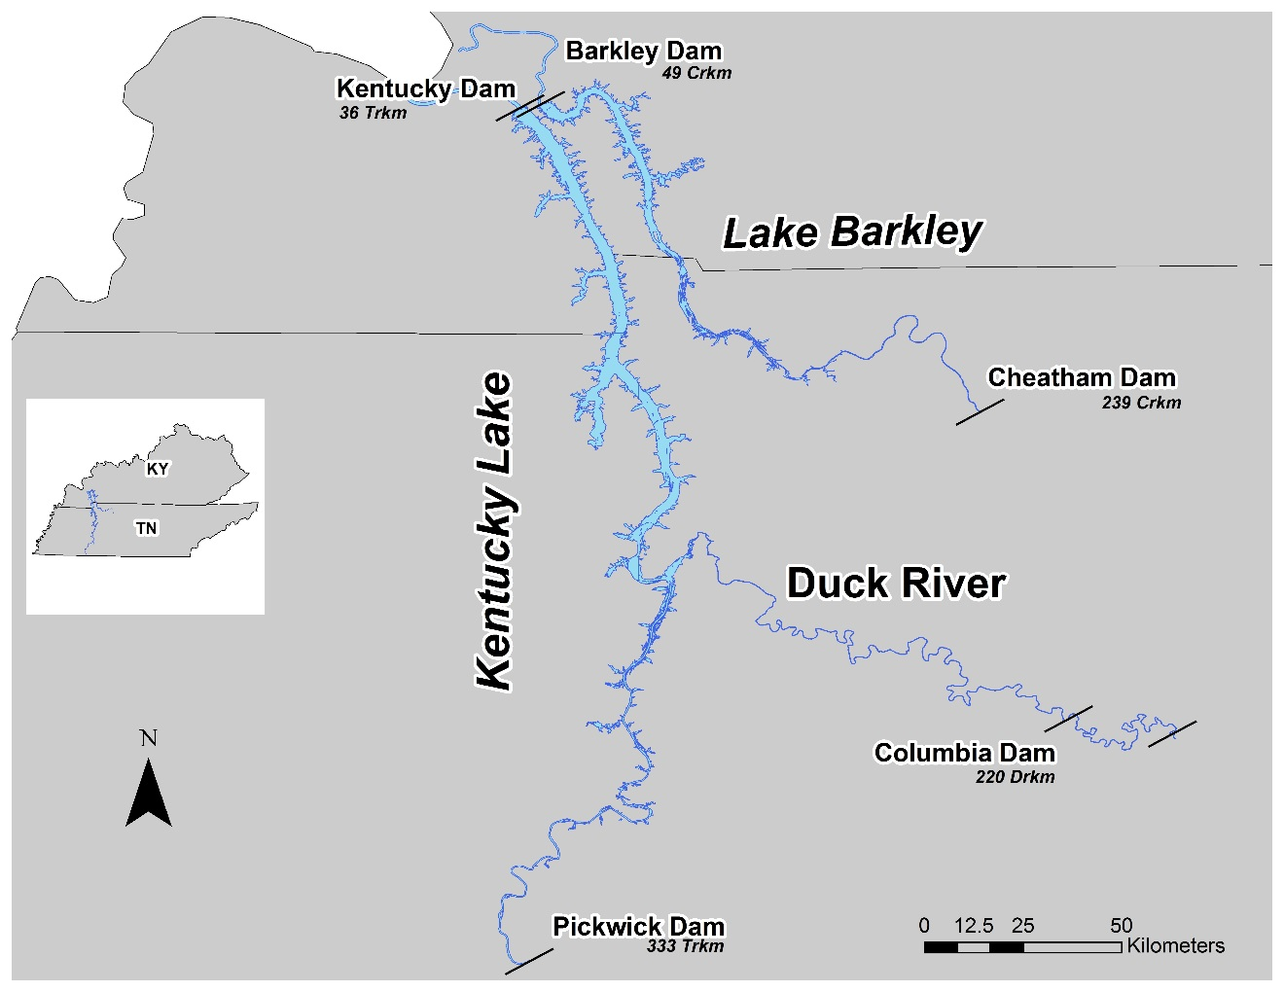

Figure 1. The lower Tennessee River and Cumberland River in Tennessee and Kentucky, and the lower Duck River where bigheaded carps were sampled in 2015-2016.

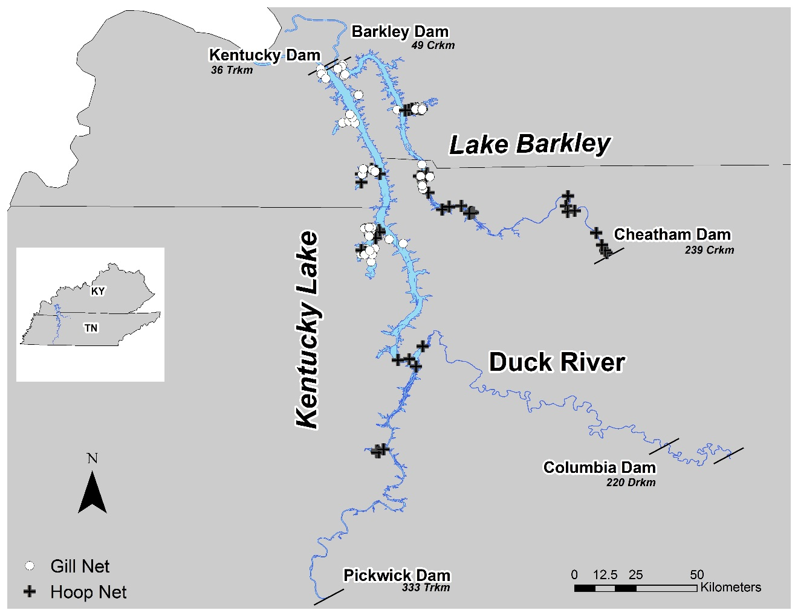

Figure 2. Locations where gill nets and hoop nets were deployed to collect bigheaded carps in 2015-2016.

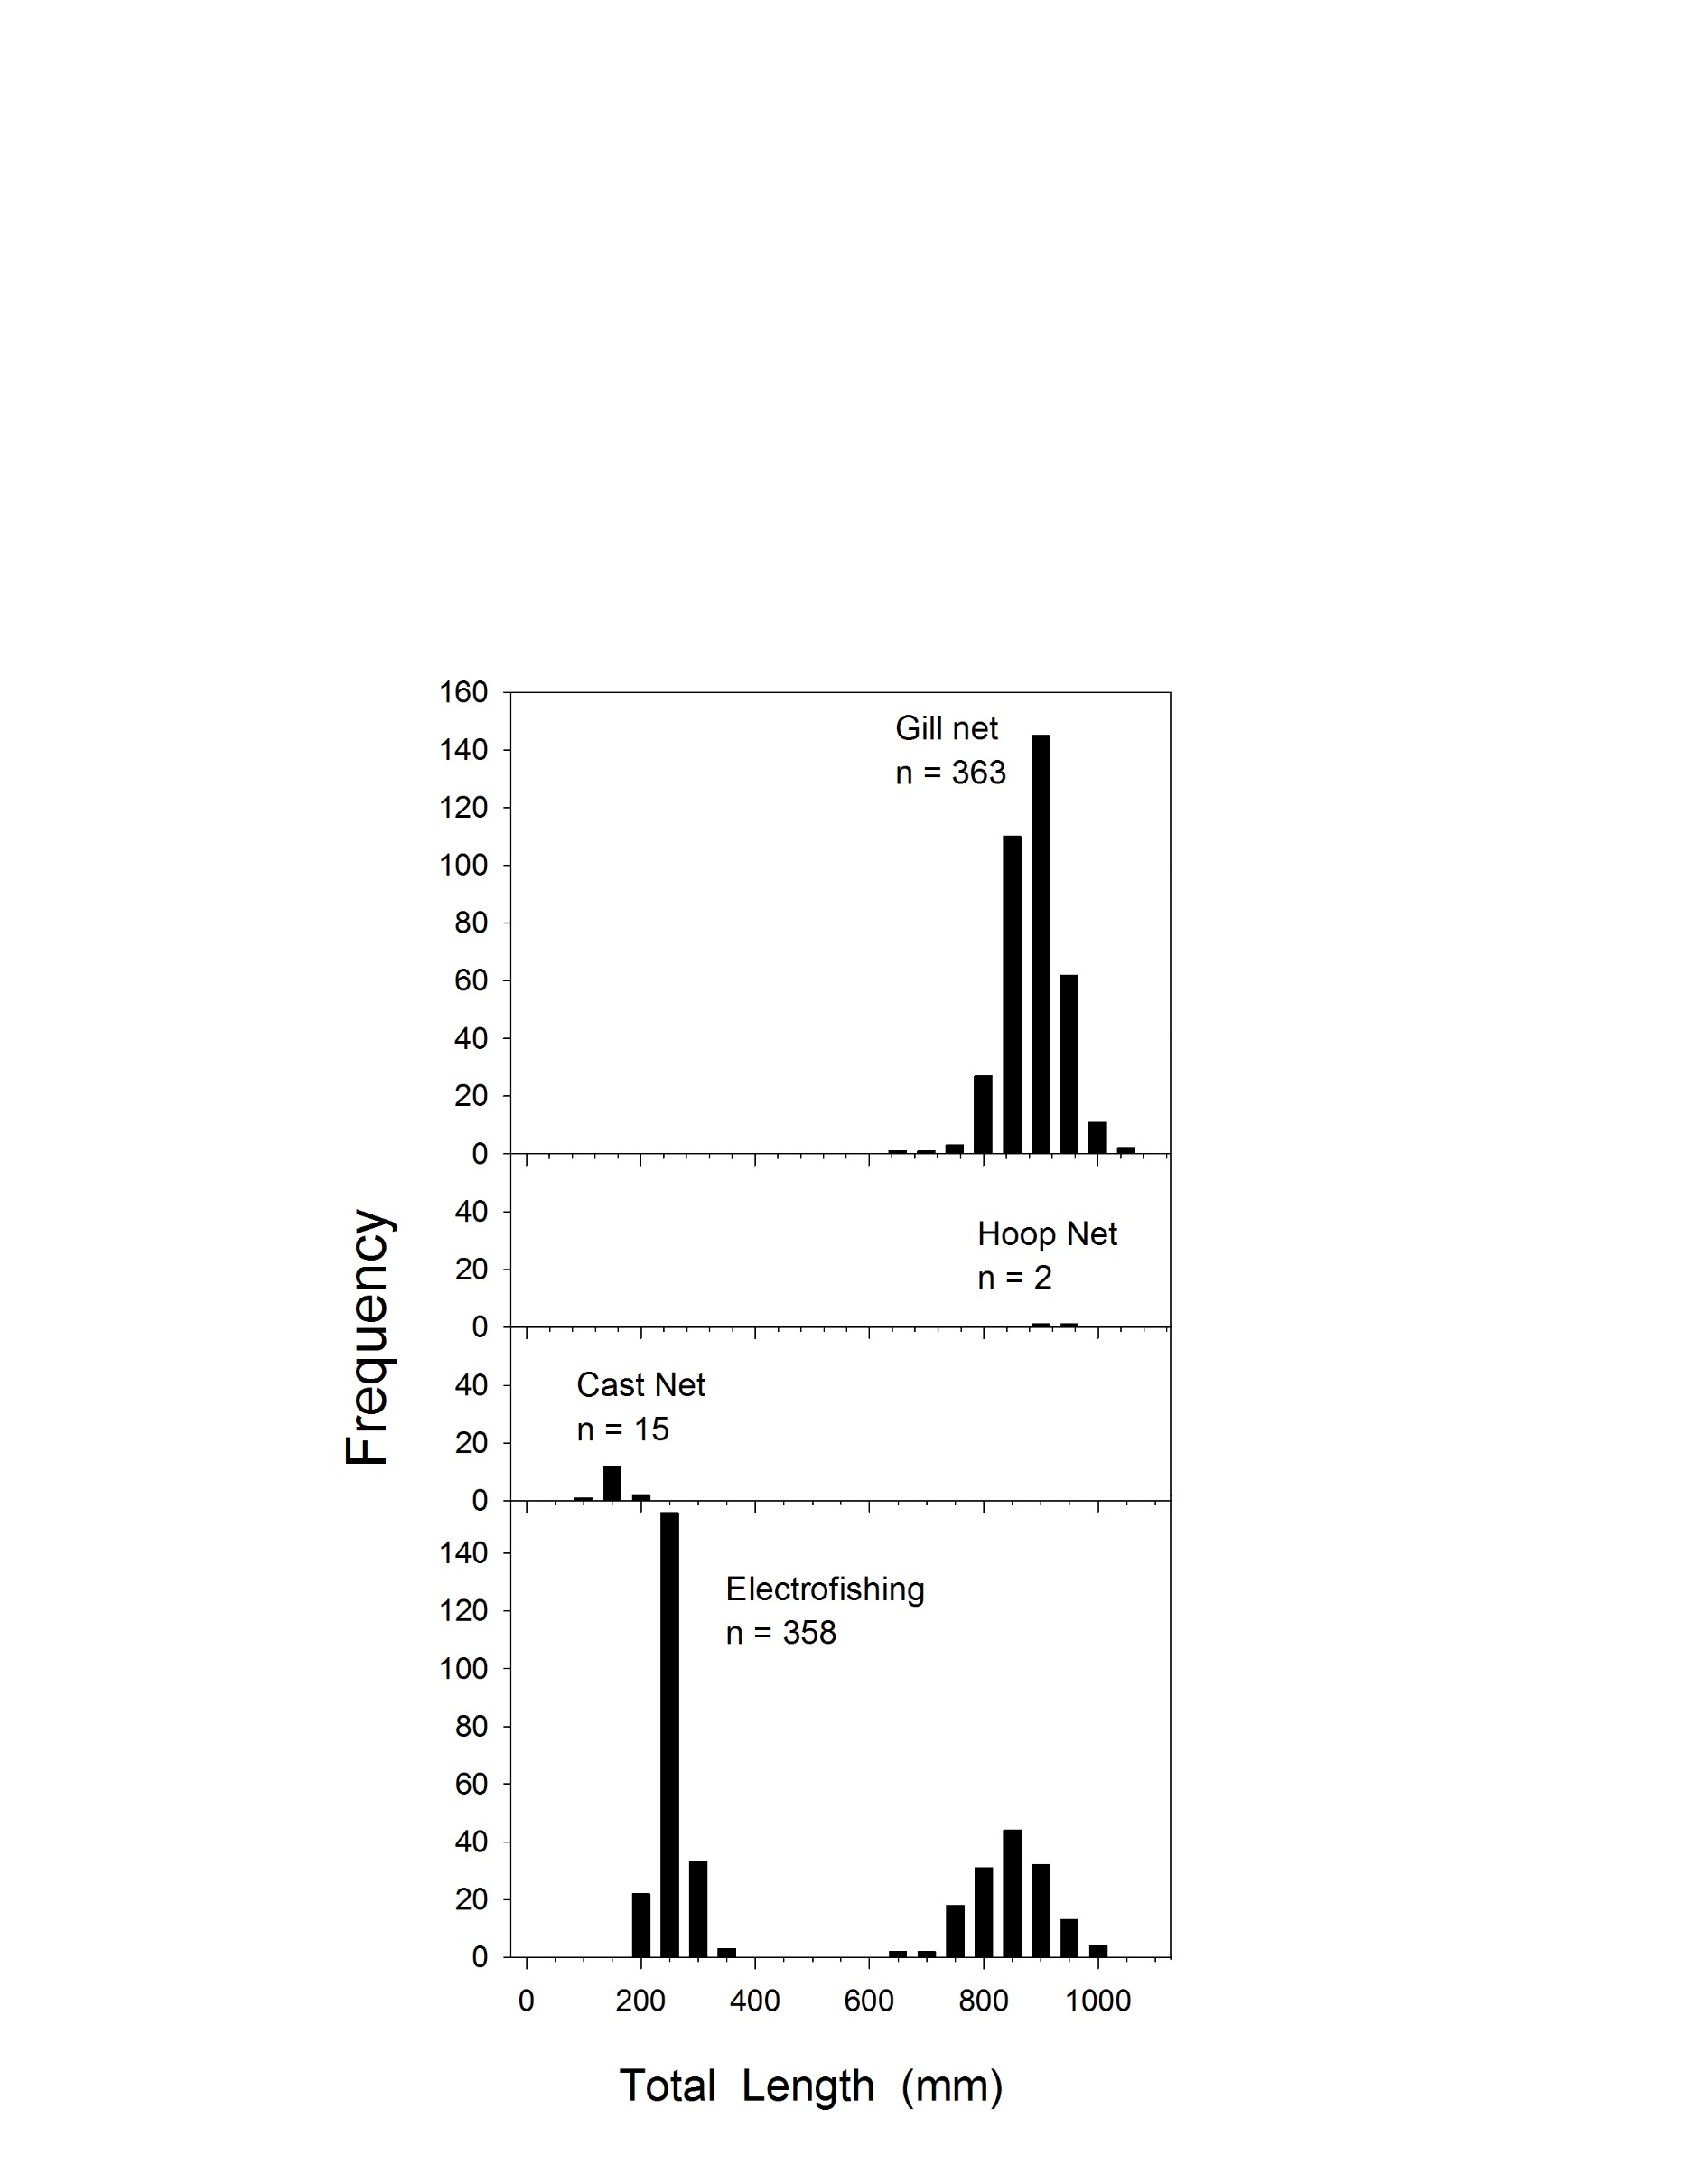

Figure 3. Total length-frequency distributions by gear type for Silver Carp captured using four different gears during standardized and exploratory, non-standardized sampling in the Tennessee River, Duck River, and Cumberland River in 2015-2016.

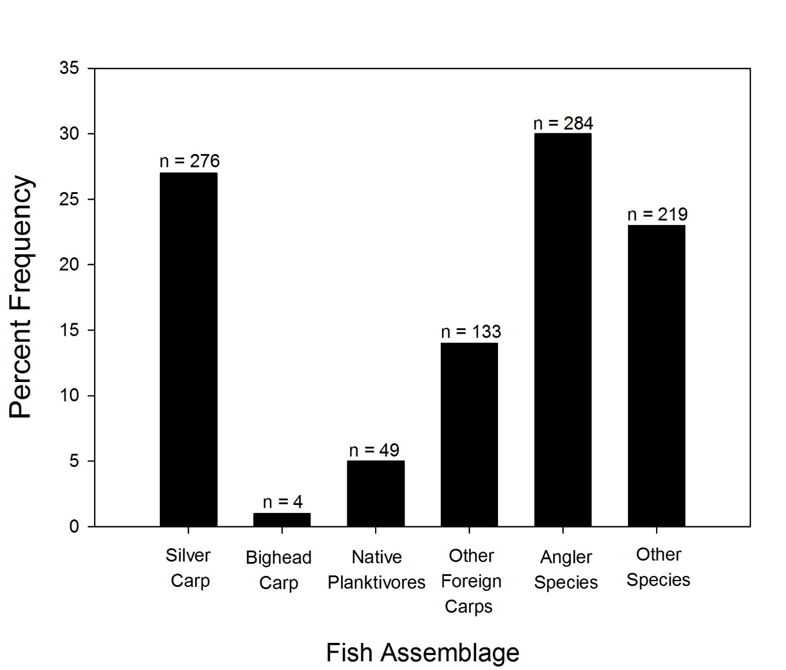

Figure 4. Percent frequency of fish collected in experimental gill nets in Kentucky Lake and Lake Barkley, 2015-2016. “Native Planktivores” are Bigmouth Buffalo*,* Gizzard Shad and Paddlefish. “Other Carps” are Grass Carp and Common Carp. “Angler Species” are represented by Centrarchidae (4 species), Cluepidae (1 species), Ictaluridae (3 species), and Moronidae (3 species). “Other Species” are represented by Amiidae (1 species), Catostomidae (3 species), Lepisosteidae (3 species) and Sciaenidae (1 species).

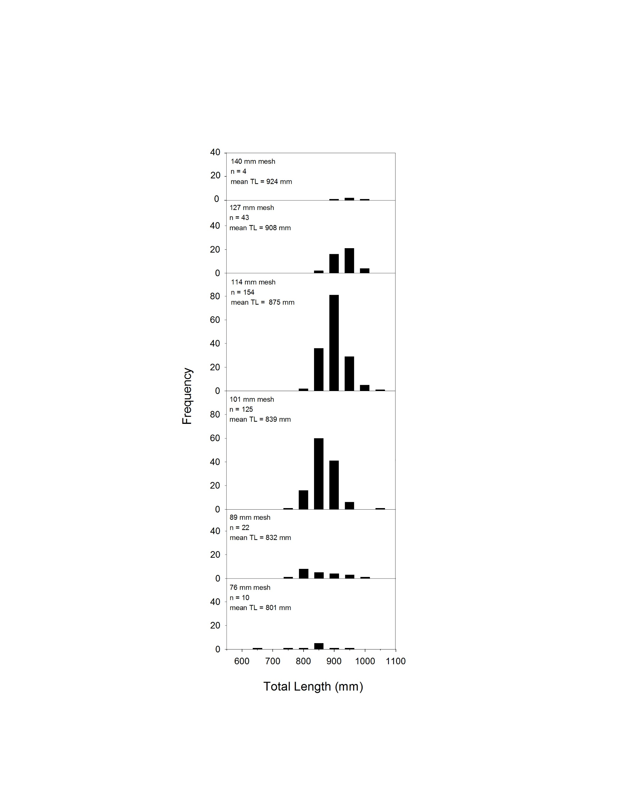

Figure 5. Total length-frequency distributions by mesh size for Silver Carp collected in gill nets during standardized and exploratory, non-standardized sampling from the lower Tennessee and Cumberland rivers, 2015-2016.

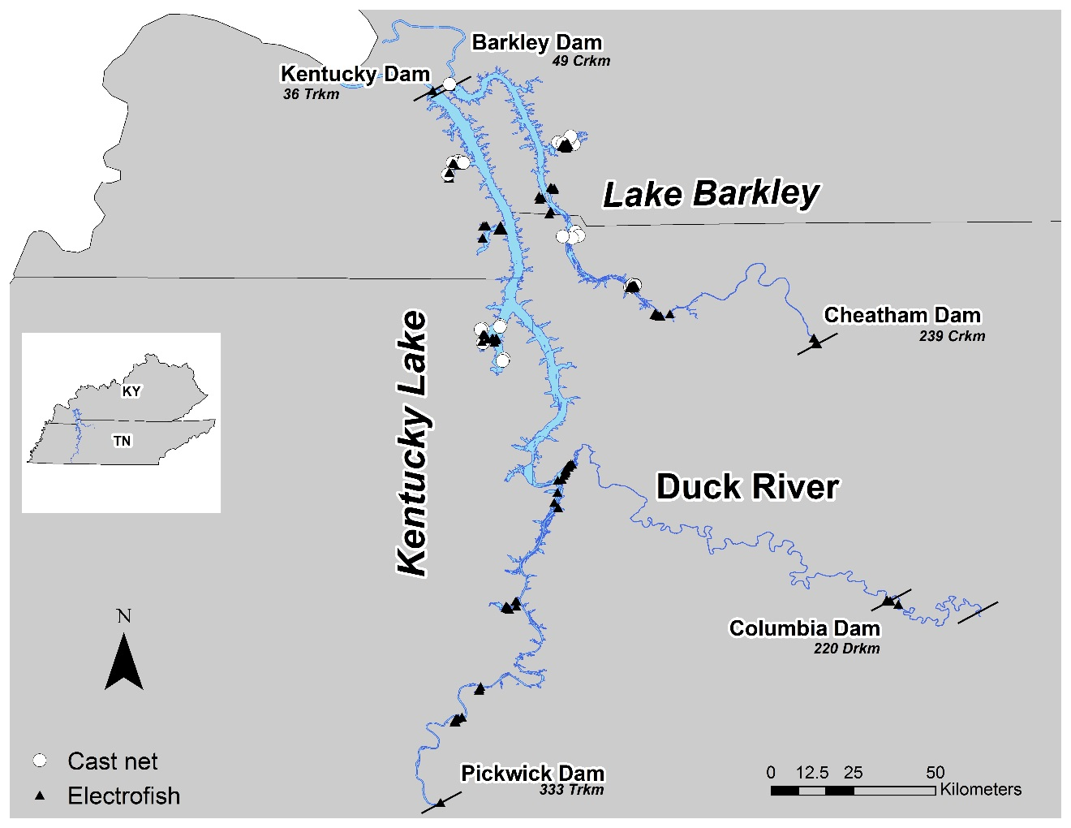

Figure 6. Locations where cast nets and electrofishing samples were collected, 2015-2016.

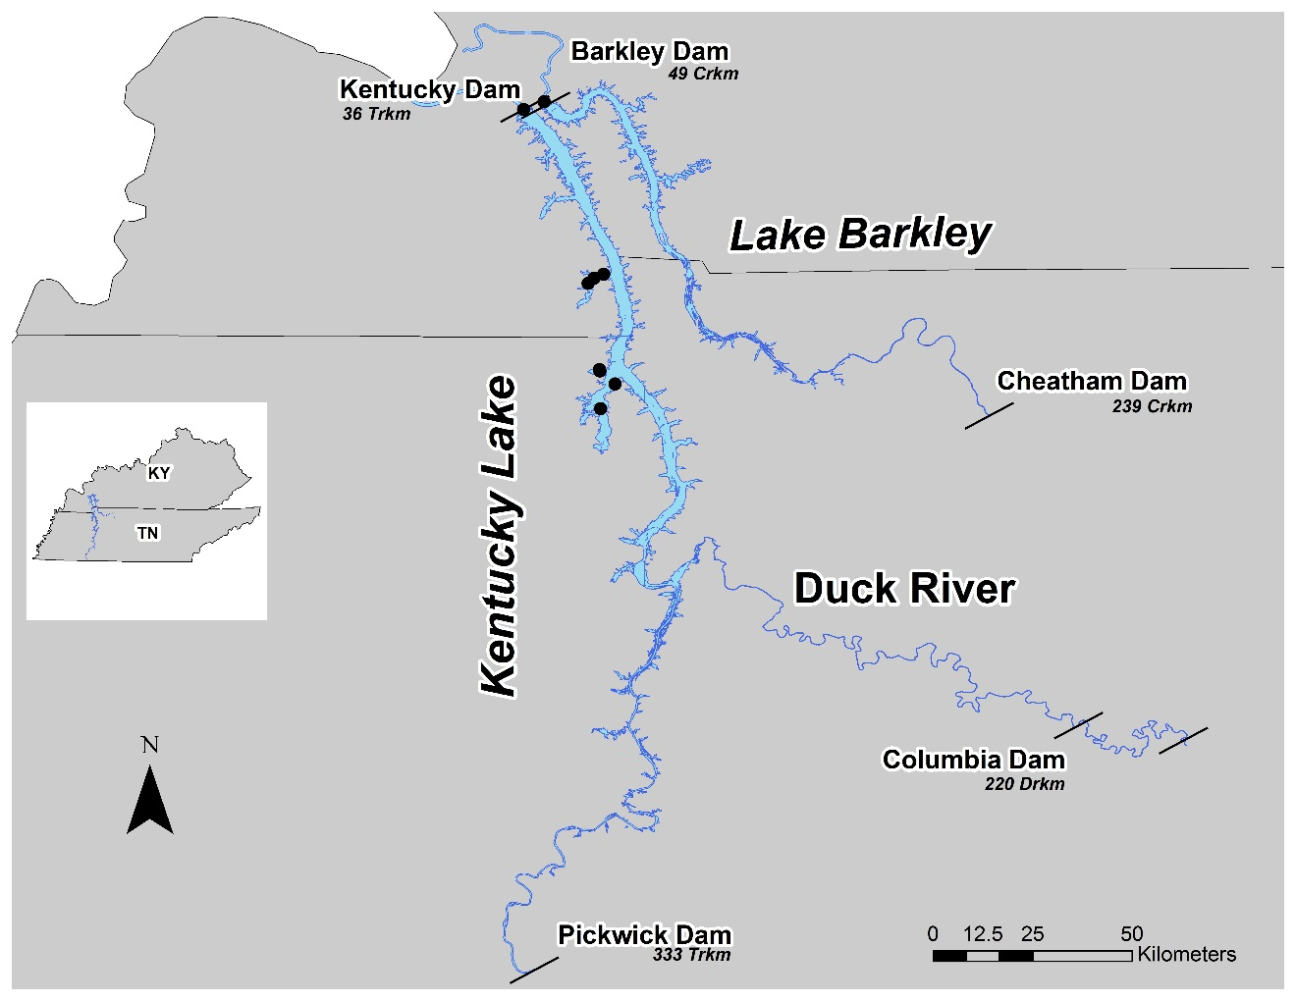

Figure 7. Locations where 10 Bighead Carp were collected, 2015-2016.

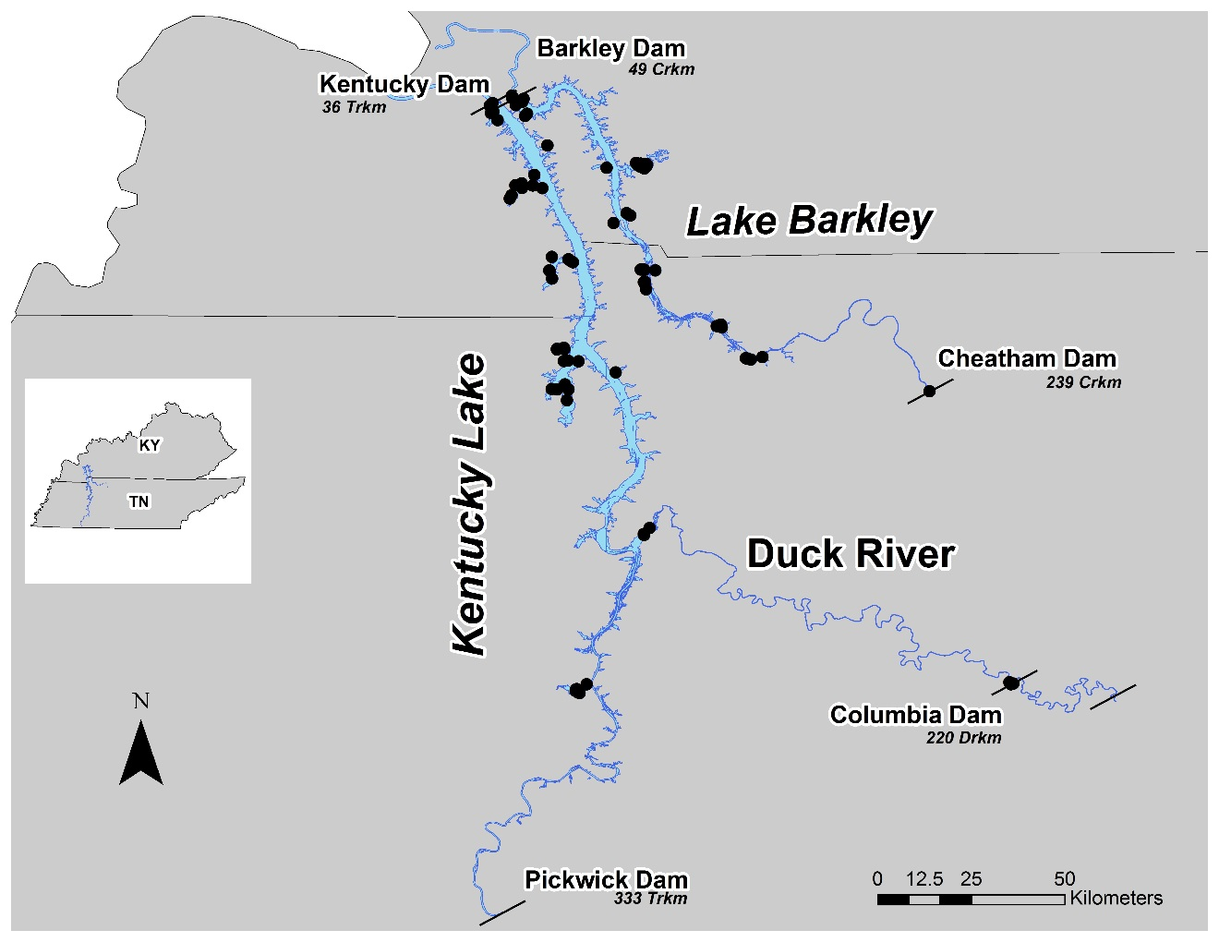

Figure 8. Locations where 787 Silver Carp were collected in 2015-2016. Three Silver Carp were observed but not captured in the Pickwick Dam tailwater.

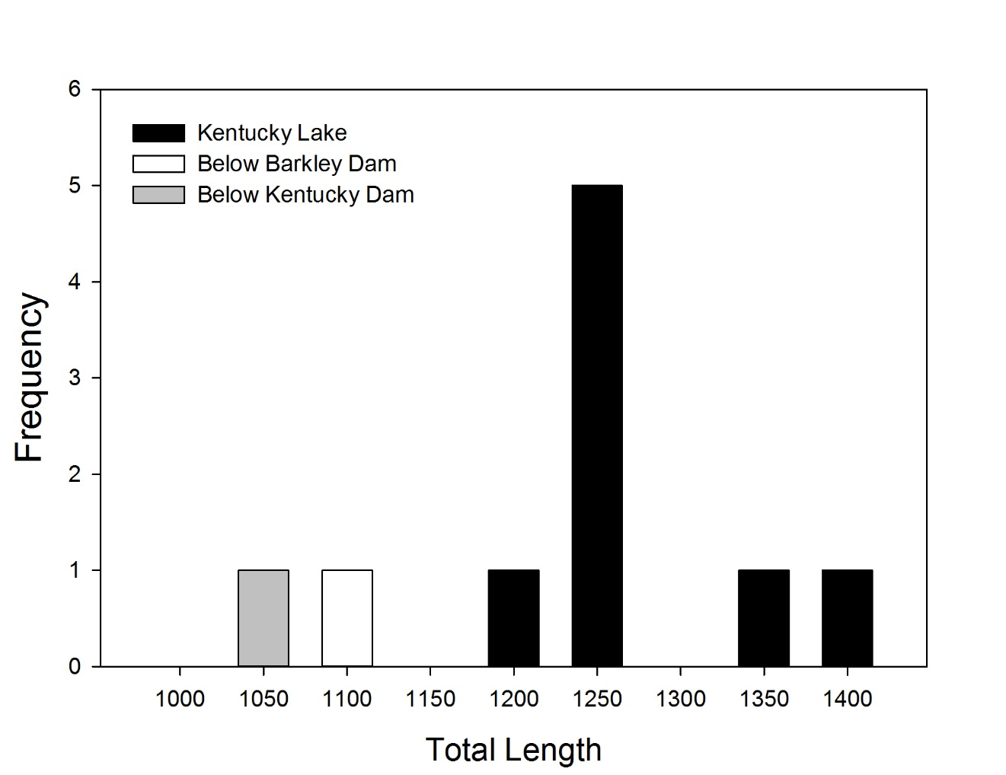

Figure 9. Total length-frequency distributions for Bighead Carp collected in Kentucky Lake and below Kentucky Dam and Barkley Dam, 2015-2016.

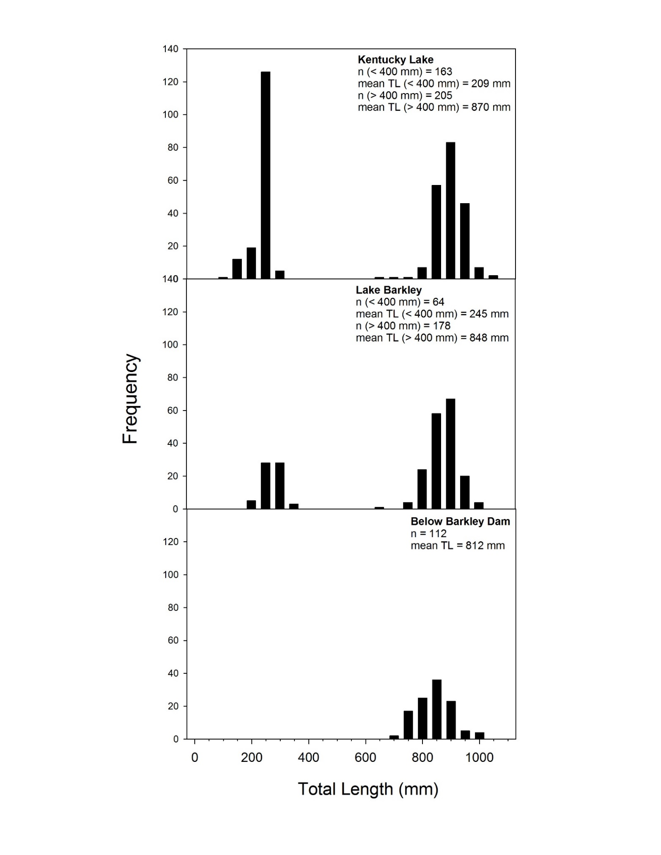

Figure 10. Total length-frequency distributions for Silver Carp collected using all gears during standardized and exploratory, non-standardized sampling in Kentucky Lake, Lake Barkley, and below Barkley Dam in 2015-2016.

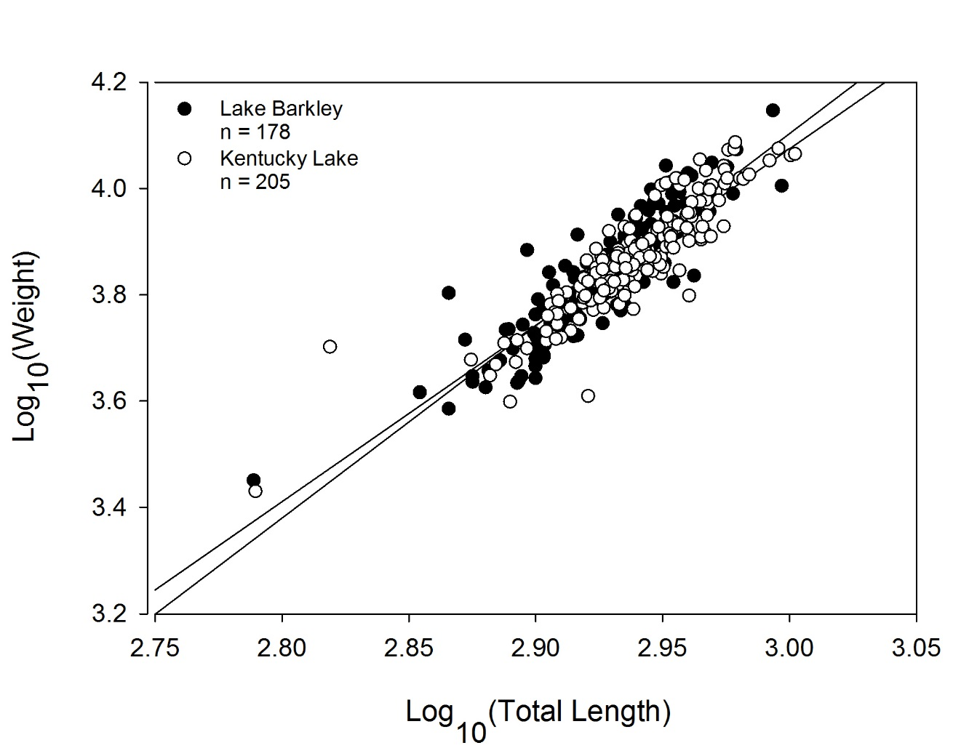

Figure 11. Log10total length – log10weight relationships for Silver Carp longer than 400 mm collected in Kentucky Lake and Lake Barkley, 2015-2016.

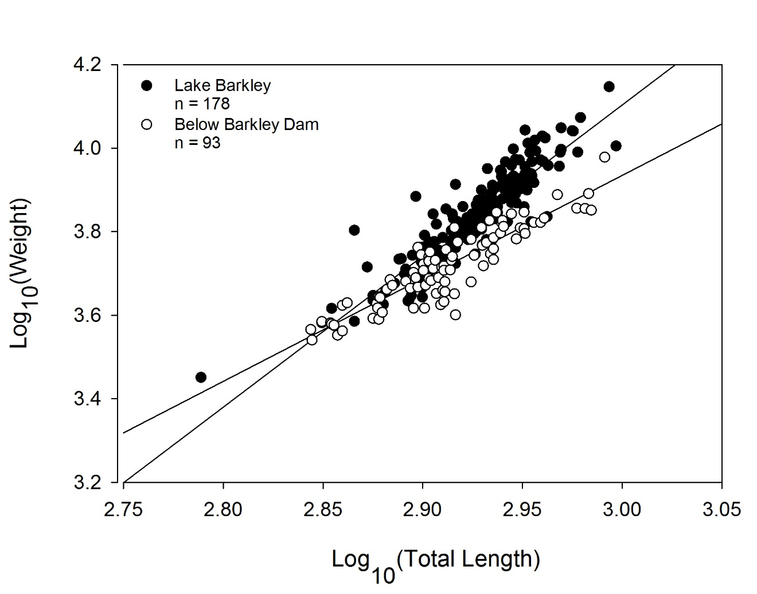

Figure 12. Log10total length – log10weight relationships for Silver Carp longer than 400 mm collected in Lake Barkley and below Barkley Dam, 2015-2016.

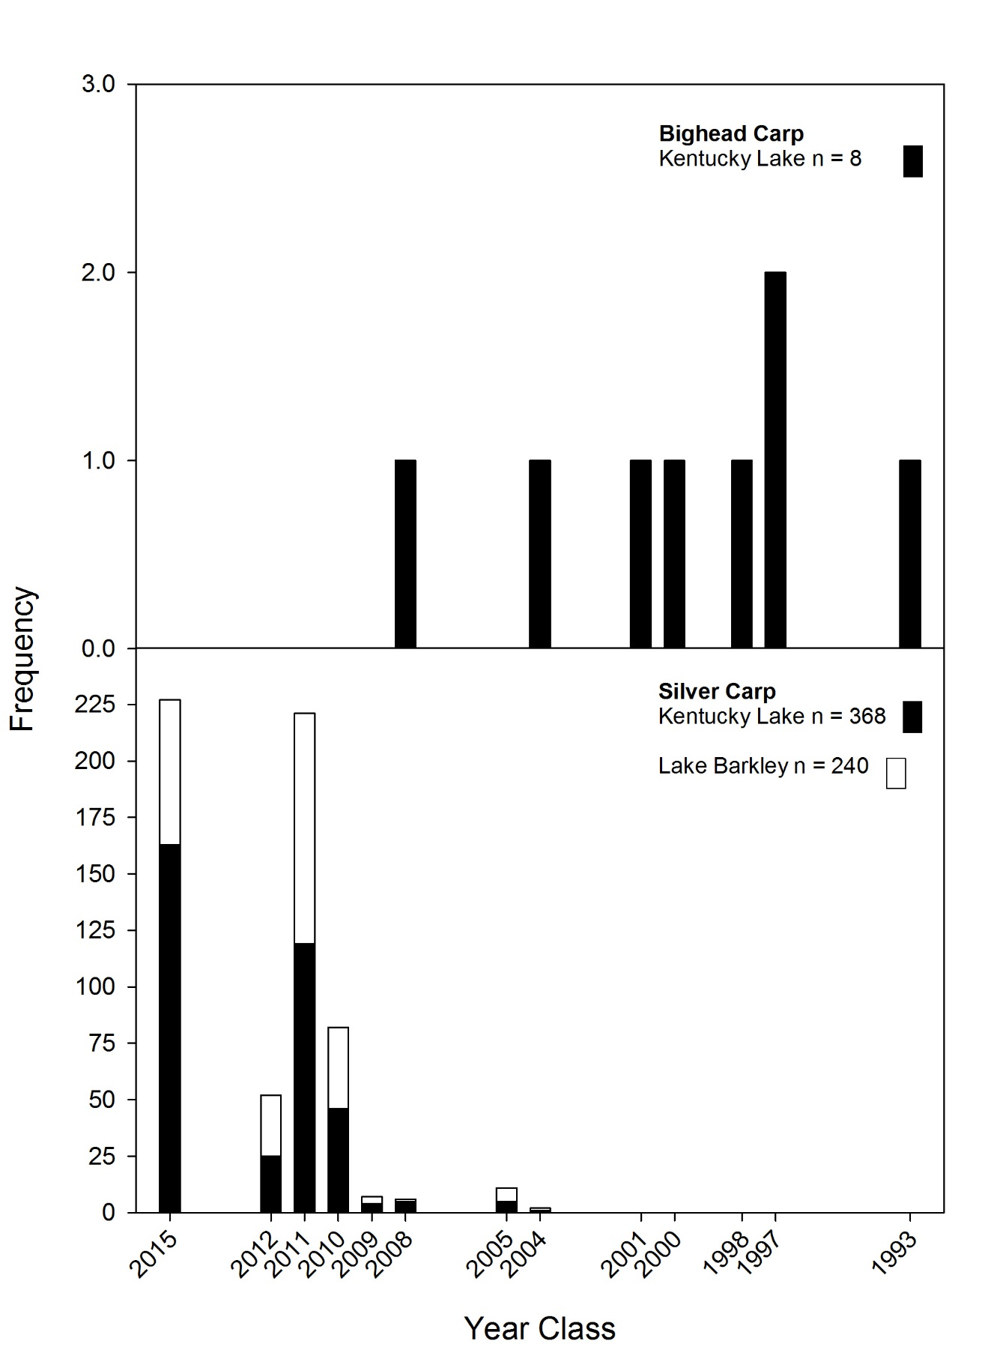

Figure 13. Year classes of Bighead Carp and Silver Carp collected from Kentucky Lake and Lake Barkley using all gears during standardized and exploratory, non-standardized sampling in 2015-2016.

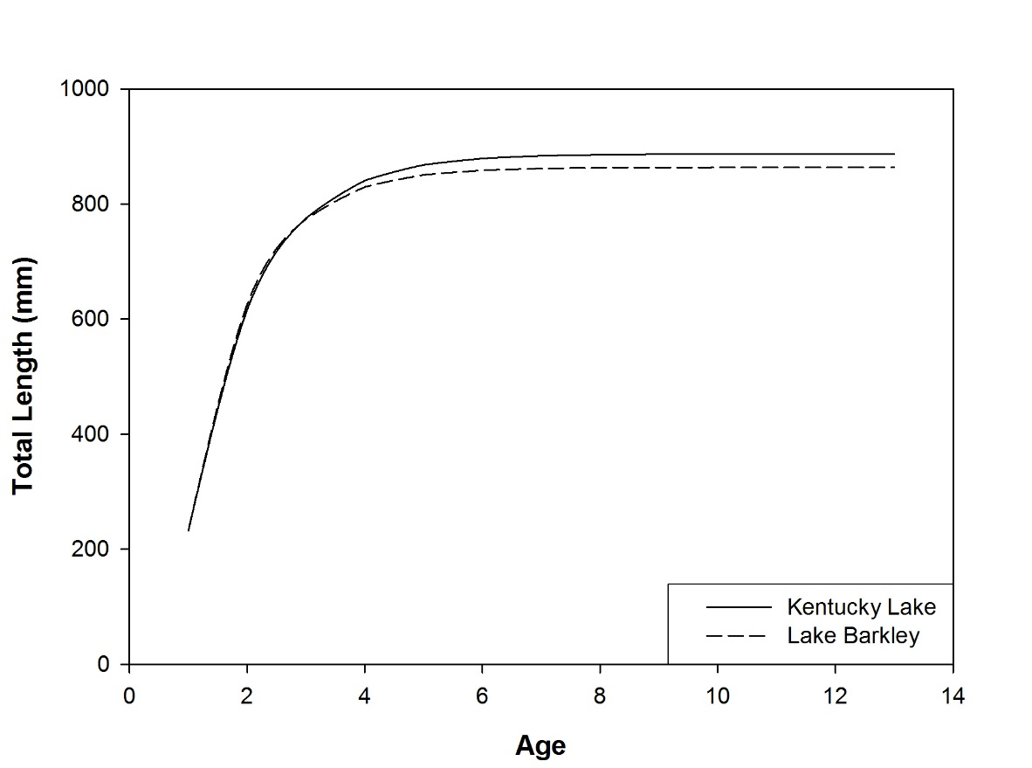

Figure 14. Von Bertalanffy growth curves for Silver Carp in Kentucky Lake and Lake Barkley, 2015-2016.

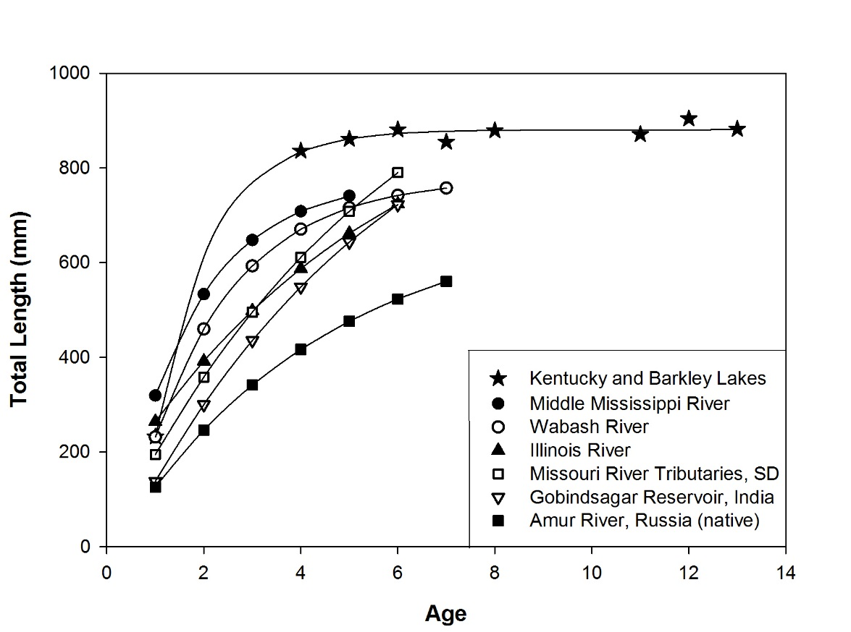

Figure 15. Von Bertalanffy growth curves for Silver Carp in Kentucky Lake and Lake Barkley (this study; observed mean-lengths-at-age are shown), Middle Mississippi River (Williamson and Garvey 2005), Wabash River in Illinois, and the Illinois River (Stuck et al. 2005), Missouri River tributaries in South Dakota (Hayer et al. 2014), India (Tandon et al. 1993 cited in Williamson and Garvey 2005), and Russia (Nikolskii 1961 cited in Williamson and Garvey 2005).

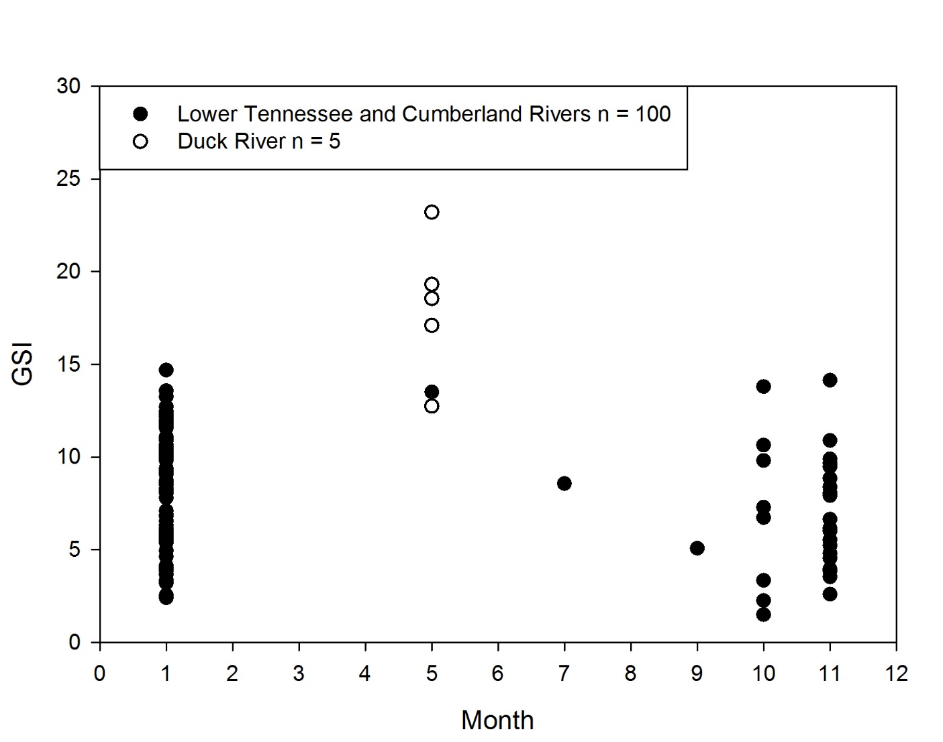

Figure 16. Gonadosomatic index across months (2015 May – December, and 2016 January) for Silver Carp collected from the lower Tennessee and Cumberland rivers, and the Duck River below Columbia Dam.

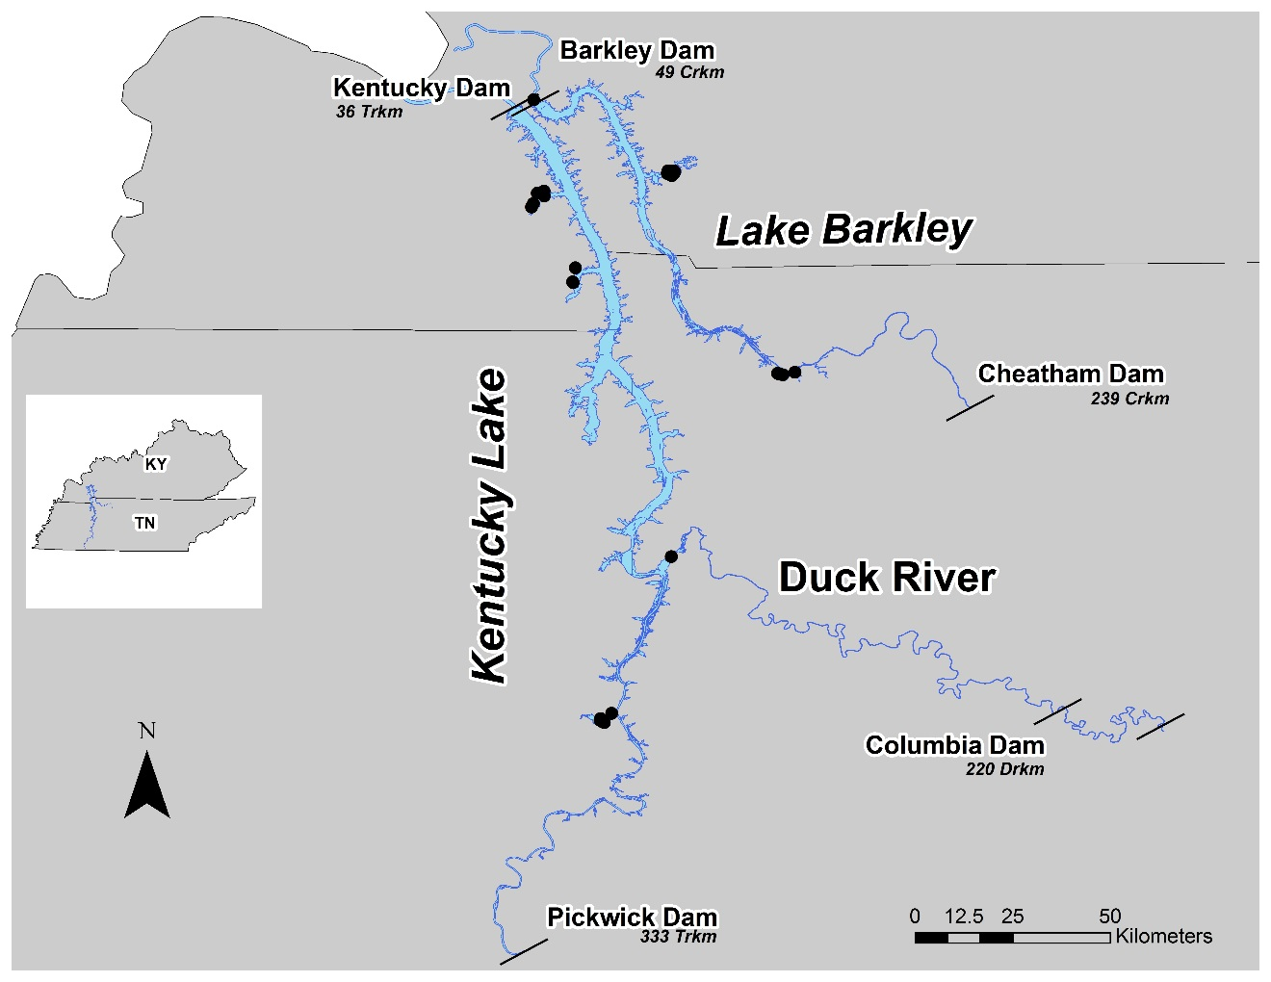

Figure 17. Locations where 264 YOY Silver Carp were collected, 2015-2016.

**APPENDIX**

**GILL NET DATA**

Table 1. Species collected using experimental gill nets in Kentucky Lake and Lake Barkley, 2015-2016.

**VITA**

Josey Ridgway was raised south of High Hill, Missouri near Pinnacle Lake Estates. He graduated from Warren County High School in 2006, and earned his Associate of Arts in General Education at St. Charles Community College in 2009. While attending the University of Missouri – Columbia, he worked as a technician for the Missouri Cooperative Fish and Wildlife Research Unit, and was a McNair Scholar. After graduating with his Bachelor of Science in Fisheries and Wildlife in 2014, he immediately entered Tennessee Technological University. In August 2016, he earned his Master of Science degree in Biology.